**Midterm – 2: Practical**

**Q7: Cloud spanner**

1. Make sure you enable cloud spanner API. If not, please go to marketplace and search for cloud spanner API.
2. Click on cloud shell icon on top right of screen. Please authorize if it asks to authorize. It does not asks for additional things since we already configured authorization during spanner creation for assignment 5. So, for now, if it will ask only below kind of dialog window

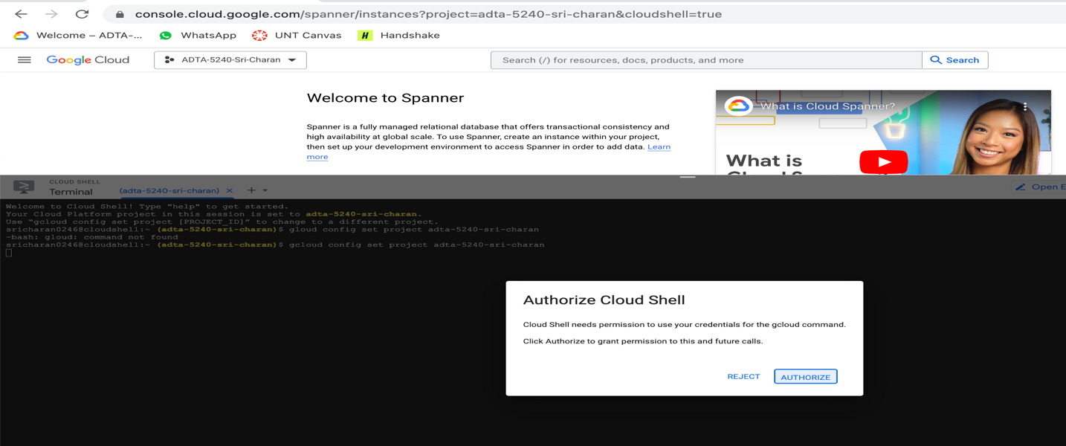

1. Create instance in cloud spanner by running below command:

gcloud spanner instances create myspanner-instance-11661666 --config=regional-us-central1 --description=“My Instance" --nodes=1

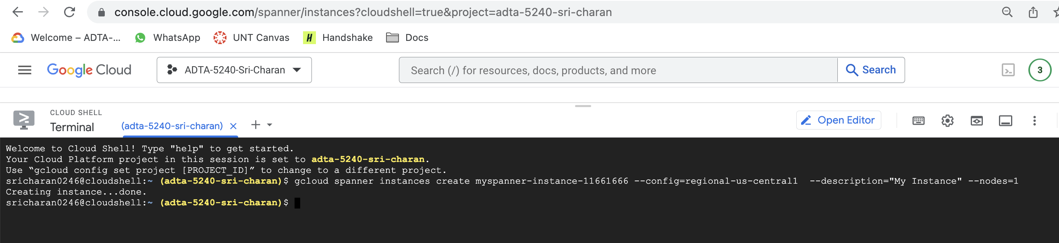

1. Now, set the newly created instance as default instance. For that, you need to run below command

gcloud config set spanner/instance myspanner-instance-11661666

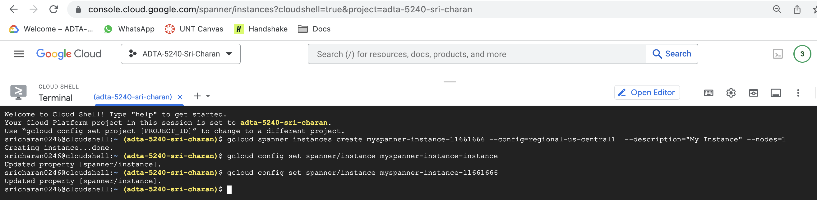

1. Create the database under instance. Database is the logical set of tables. You can run follow command

gcloud spanner databases create store-db

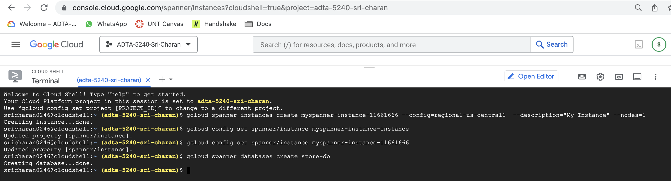

1. Create tables now. Below is the command
   1. Table 1: Customers:

gcloud spanner databases ddl update store-db --ddl='CREATE TABLE Customers ( cid INT64 NOT NULL, FirstName STRING(1024), LastName STRING(1024), phone STRING(MAX), CustomerType STRING(10) ) PRIMARY KEY (cid)’

* 1. Table 2: Items:

gcloud spanner databases ddl update store-db --ddl='CREATE TABLE Items ( itemId INT64 NOT NULL, itemName STRING(1024), price FLOAT64, discount INT64, description BYTES(MAX) ) PRIMARY KEY (itemId)’

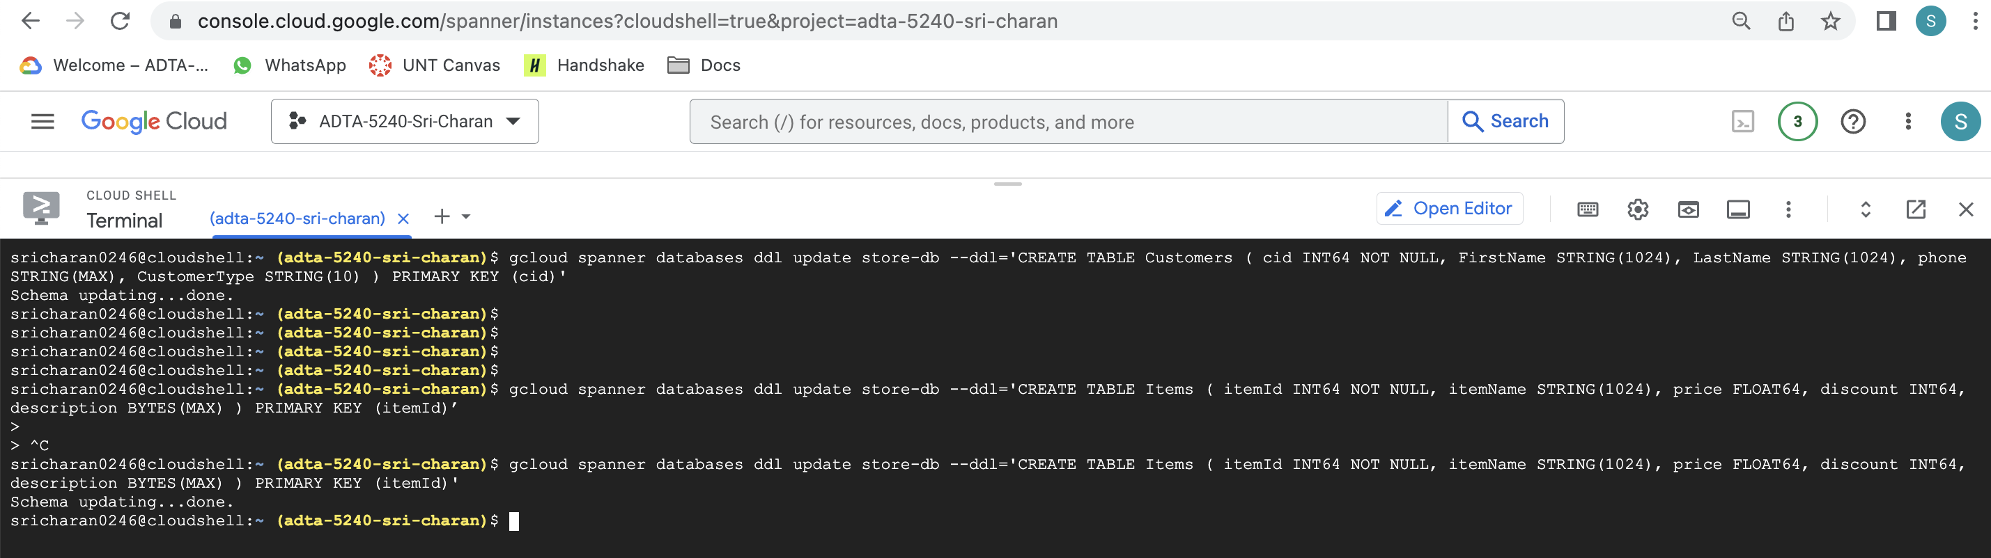

1. Now insert data into Customers tables using following command:
2. gcloud spanner rows insert --database=store-db --table=Customers --data=cid=1,FirstName=Jack,LastName=Doe,phone=9898989898,CustomerType=Preferred;
3. gcloud spanner rows insert --database=store-db --table=Customers --data=cid=2,FirstName=John,LastName=Kelly,phone=1234567890,CustomerType=Regular;
4. gcloud spanner rows insert --database=store-db --table=Customers --data=cid=3,FirstName=Alison,LastName=Darry,phone=0987654321,CustomerType=Preferred;
5. gcloud spanner rows insert --database=store-db --table=Customers --data=cid=4,FirstName=Kevin,LastName=Berry,phone=1122332211,CustomerType=Regular;
6. gcloud spanner rows insert --database=store-db --table=Customers --data=cid=5,FirstName=Jos,LastName=Macoy,phone=3344555544,CustomerType=Preferred;

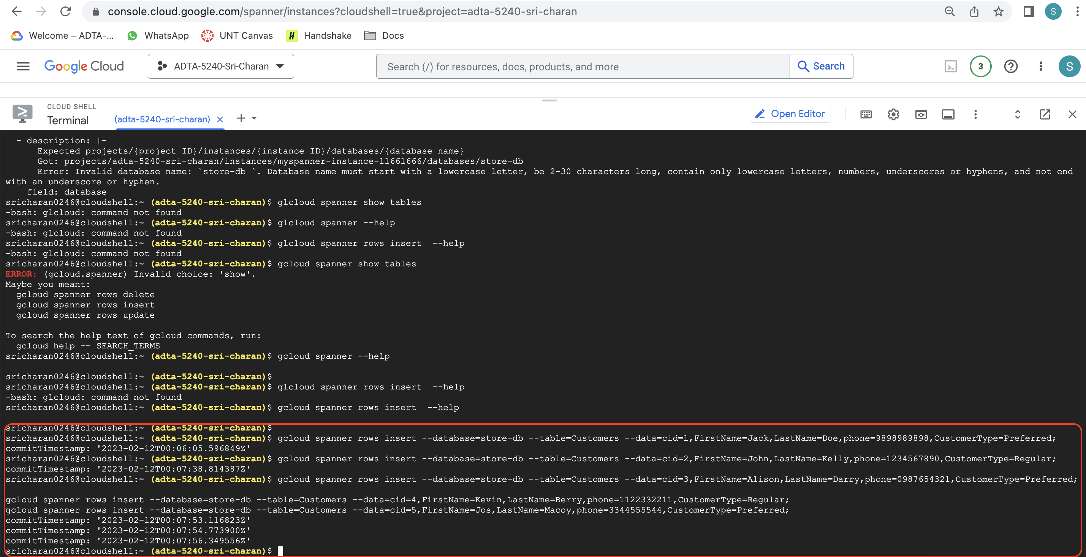

1. Insert data into Items table
   * 1. gcloud spanner rows insert --database=store-db --table=Items --data=itemId=1,itemName=iphone,price=1199.00,discount=5,description="Made by Apple";
     2. gcloud spanner rows insert --database=store-db --table=Items --data=itemId=2,itemName=ThinkPadT14,price=1499.00,discount=15,description="Made by Lenovo";
     3. gcloud spanner rows insert --database=store-db --table=Items --data=itemId=3,itemName=GalaxyZFold,price=1899.00,discount=10,description="Made by Apple";
     4. gcloud spanner rows insert --database=store-db --table=Items --data=itemId=4,itemName=4KTV,price=1099.00,discount=5,description="Made by LG";
     5. gcloud spanner rows insert --database=store-db --table=Items --data=itemId=5,itemName=CeilingFan,price=499.00,discount=5,description="Made by LG";

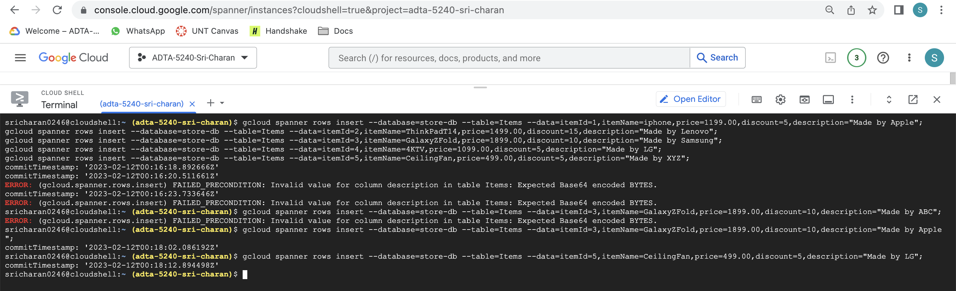

1. to view the tables on GCP web console, go to web page and refresh GCP console page. Navigate to cloud spanner and select the instance and database names. Now, you can see table at the bottom of the screen

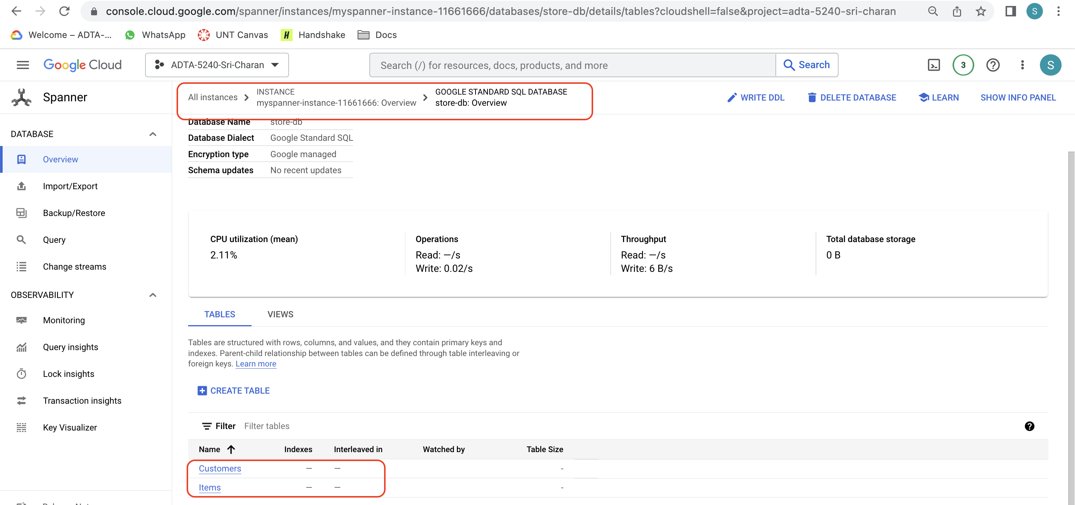

1. To view the data inside the table, click on the table name and select data on the left

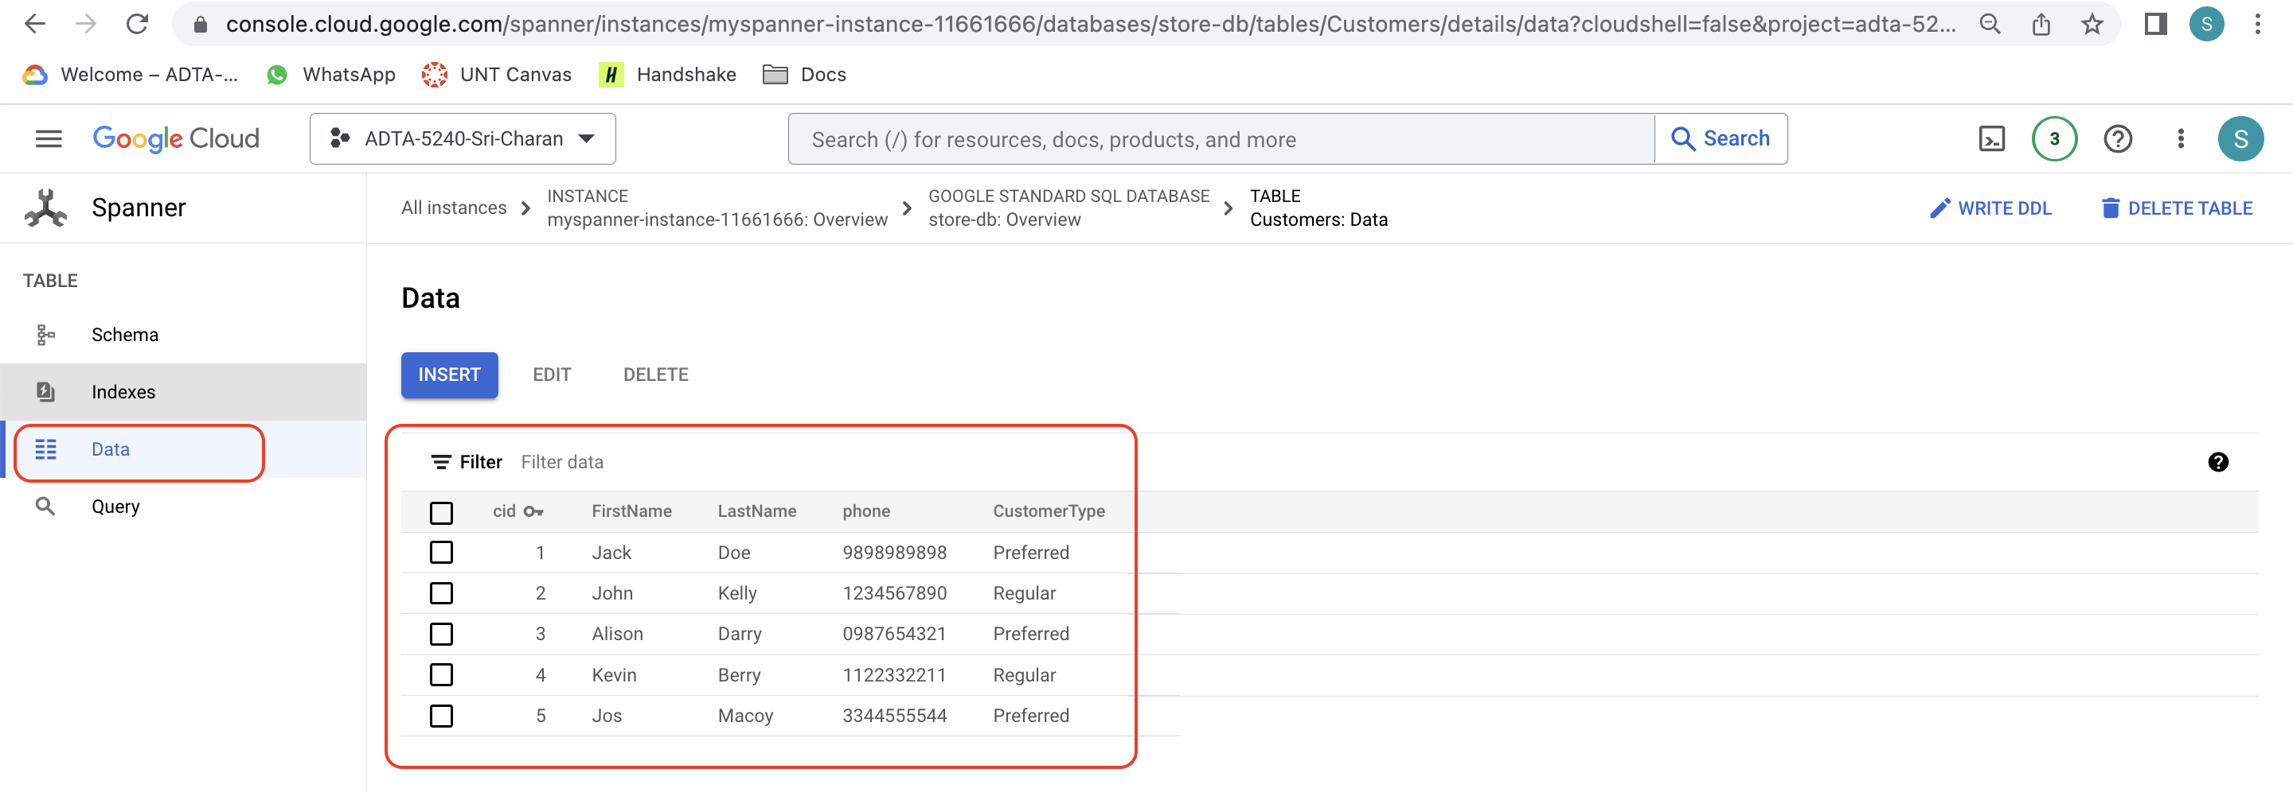

1. You can also view data inside Items table as below

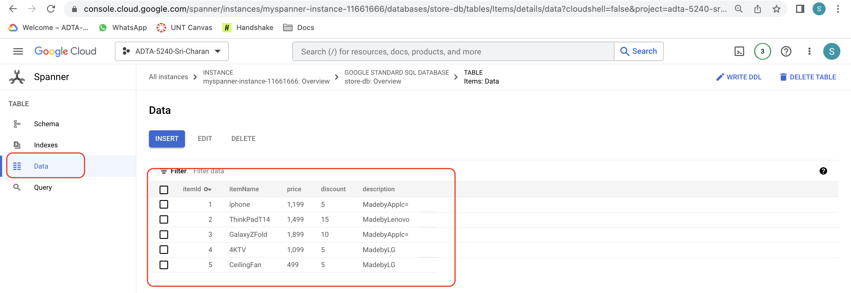

1. Make sure you delete the spanner instance after use.

**Q8: BigQuery using console**

1. At first, download the data file(babynames.zip) from modules section from canvas if you do not have in your system
2. Create dataset:
   1. Dataset need to be created first to create tables in BigQuery. Dataset is the logical set of tables you create. You can define various rules to dataset. Navigate to BigQuery service. In the explorer section, you will see your project(adta-5240-sri-charan), click on 3 dots icon just beside project name to see “Create dataset” option

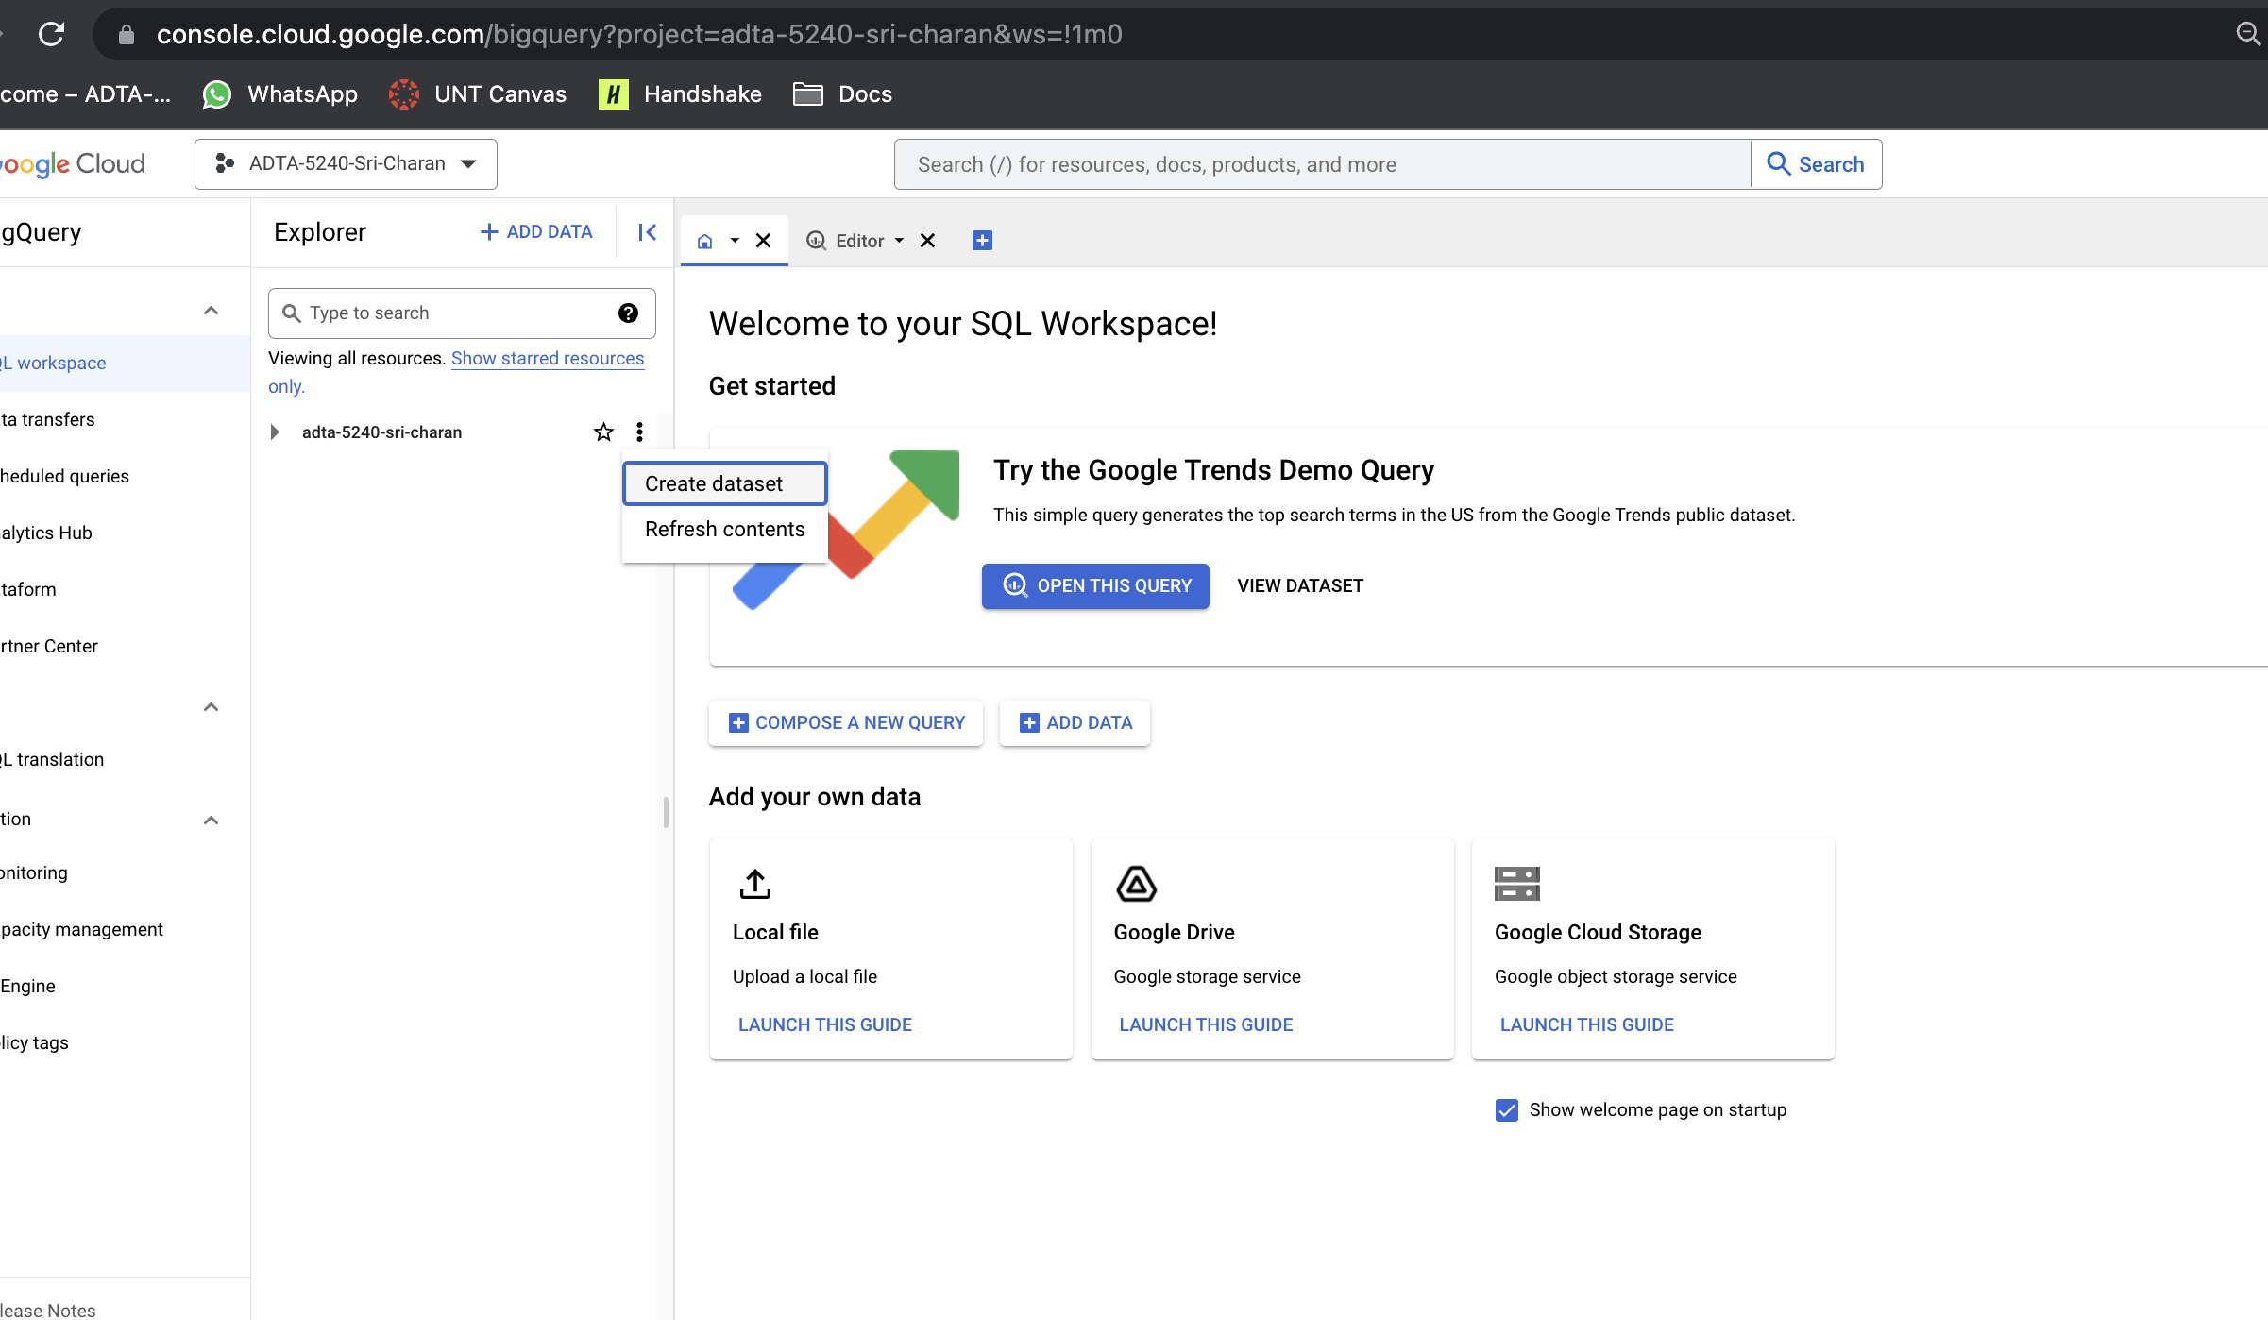

* 1. Give the name to the dataset, set to multiregion for location type and set US as multiregion location and keep other settings as default and click on “CREATE DATASET”

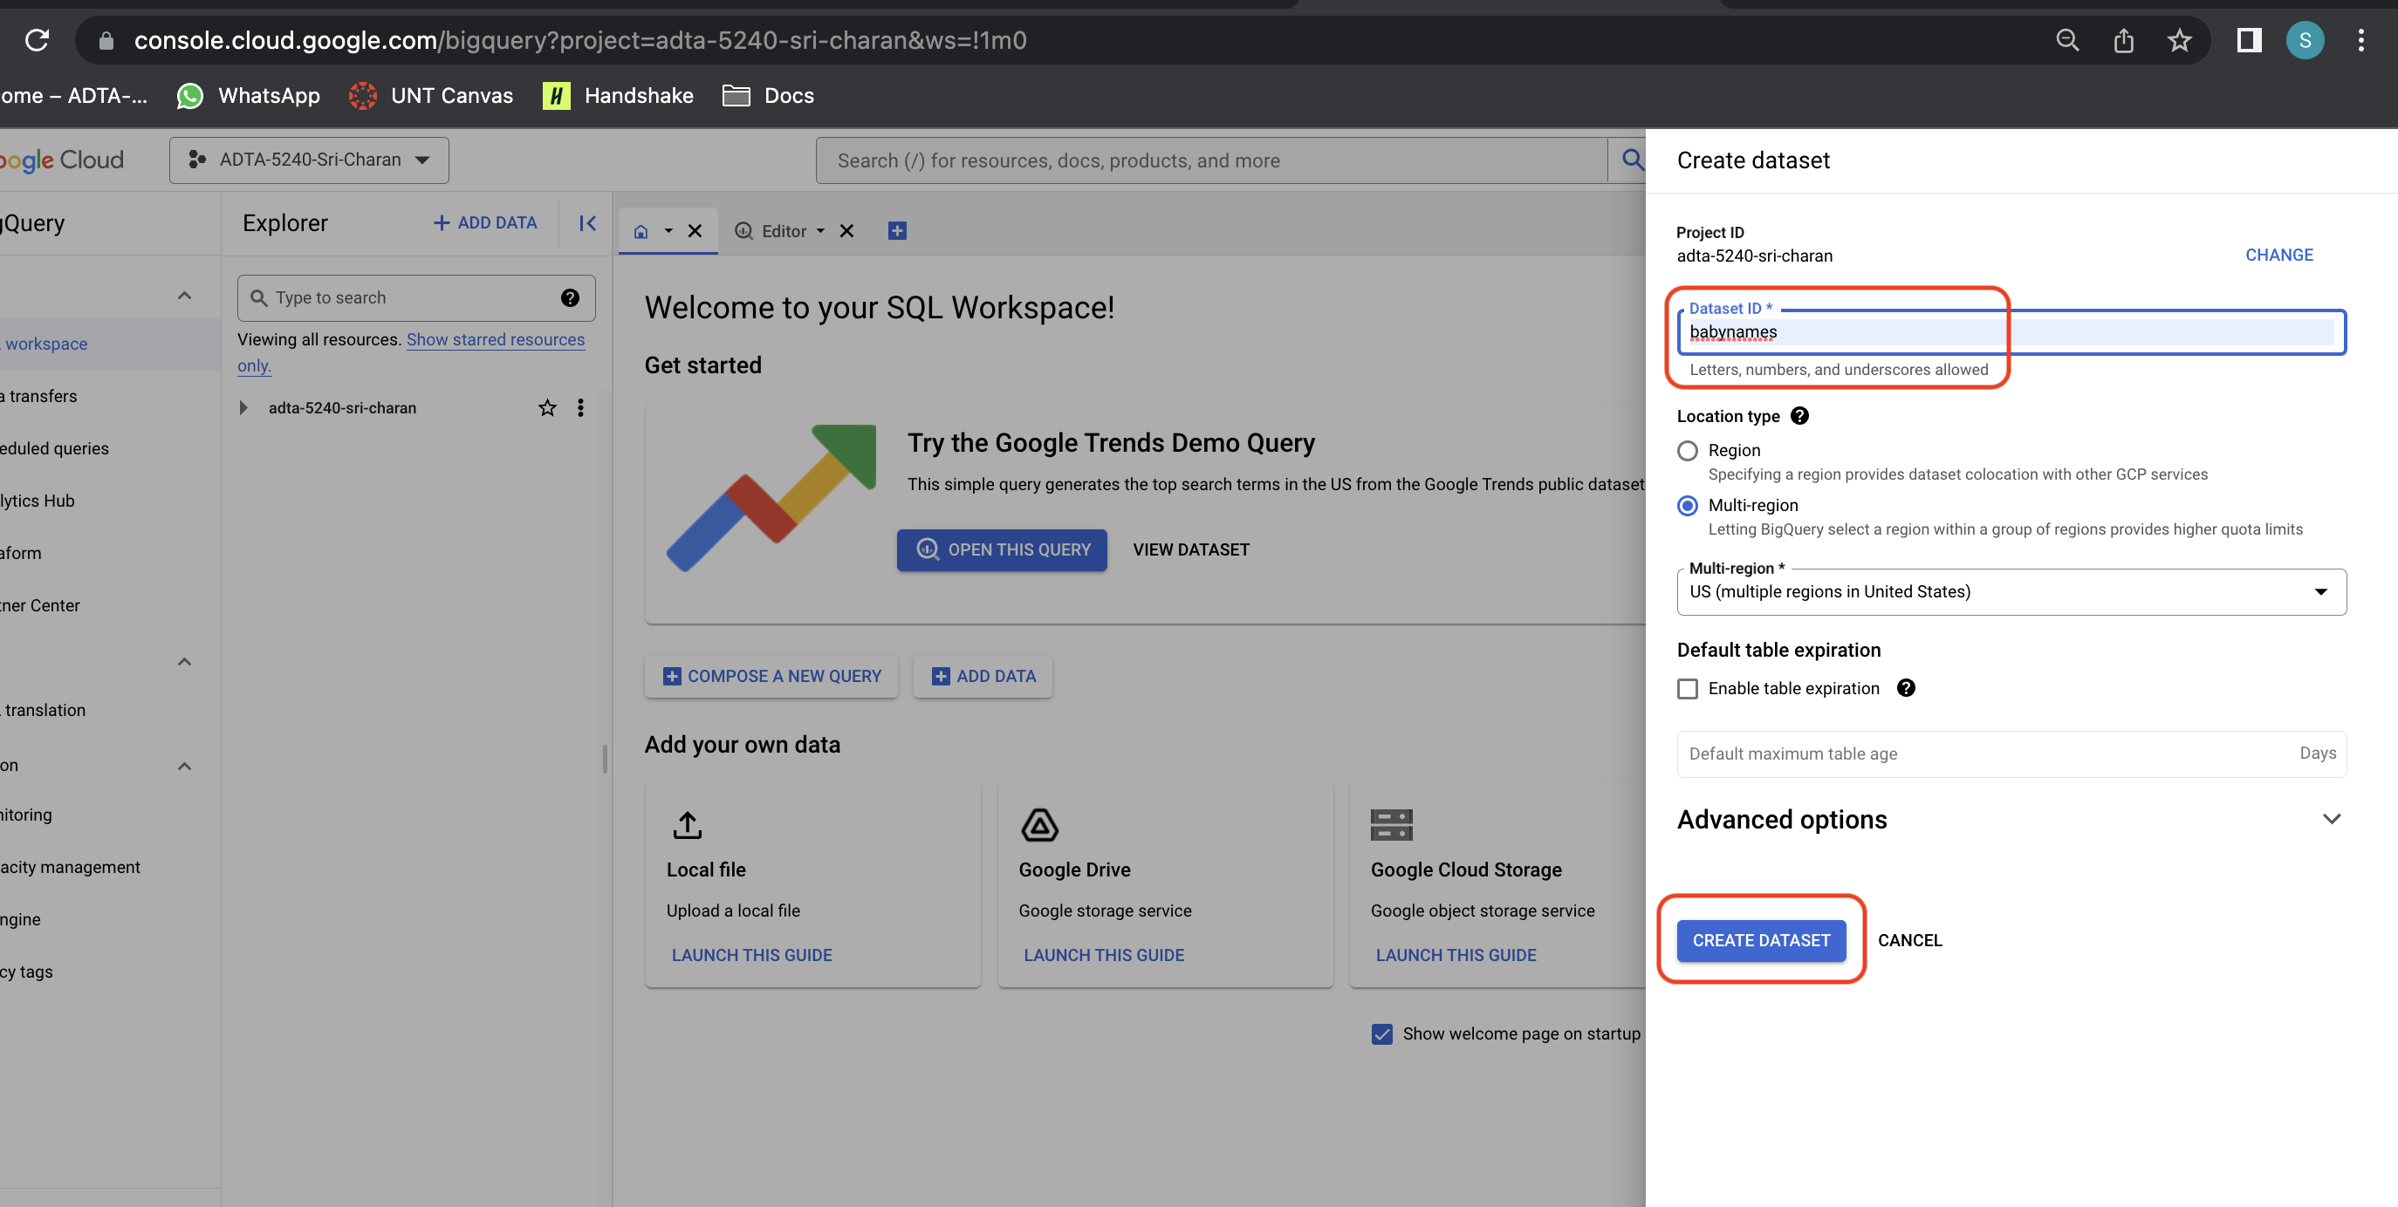

1. Now it’s time to create table under babynames dataset. Go to babynames dataset and click on “CREATE TABLE” button

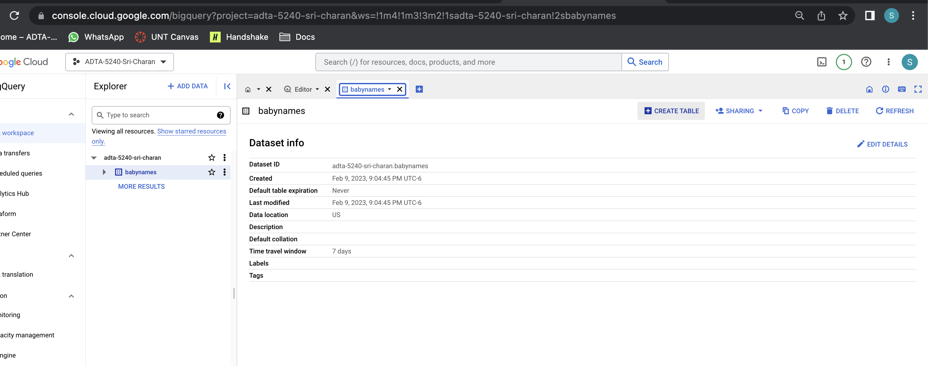

1. Give the name of the table and select the file to add rows into the table by uploading dob1954.txt from above downloaded file. Give schema of the table as “name:string, gender:string, count:integer” then click on CREATE TABLE button at bottom to create table

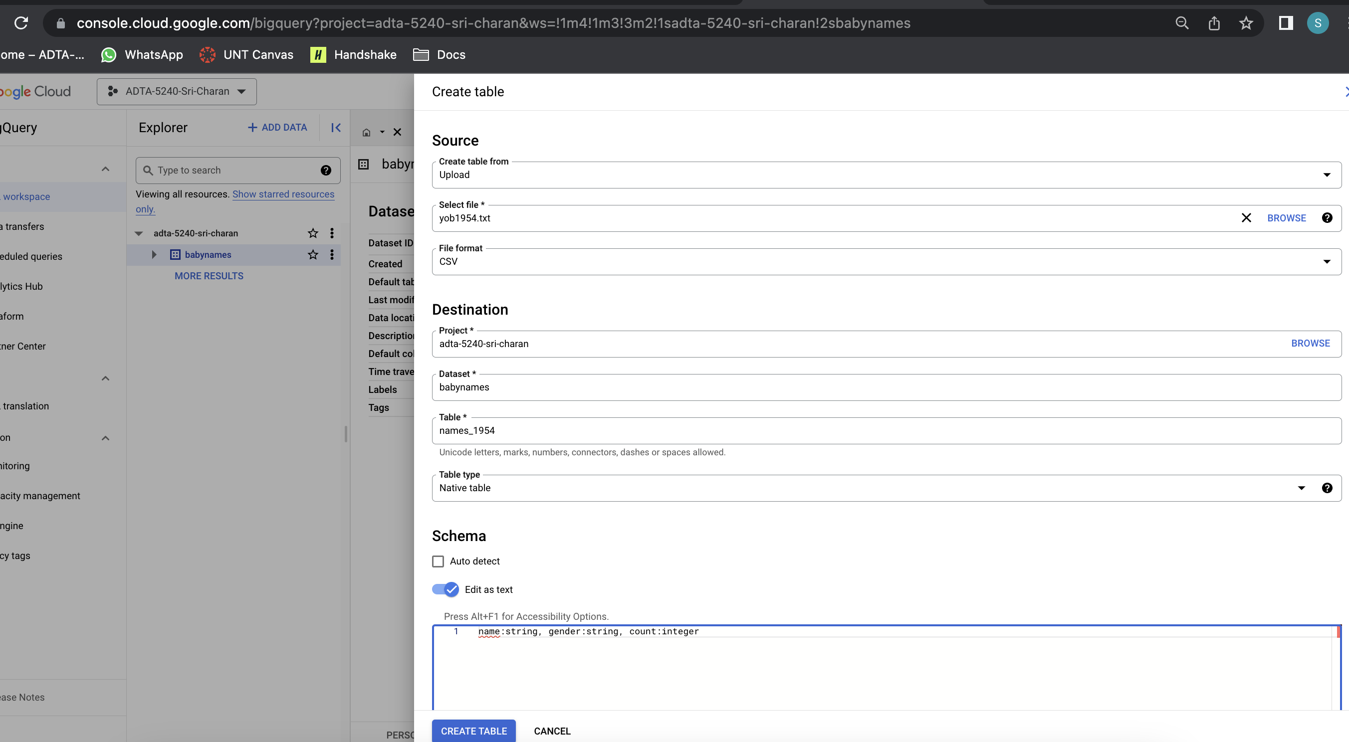

1. After few seconds, You can see table details and data load job details now

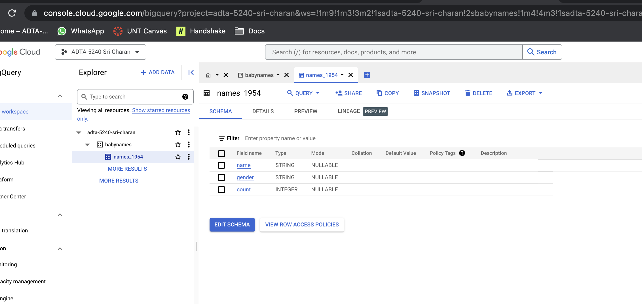

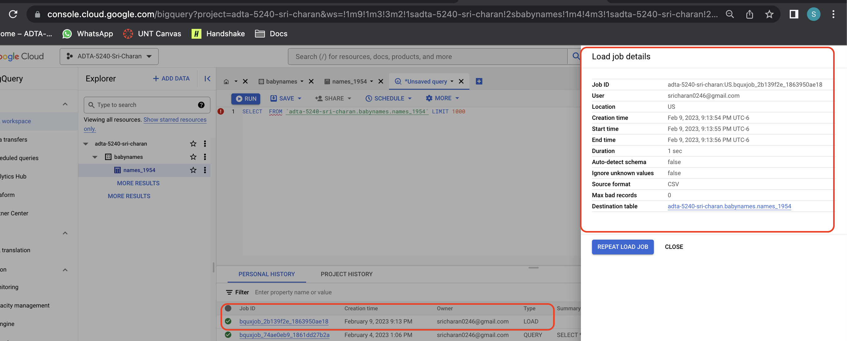

1. Now, you can preview data in the table clicking “PREVIEW” button at the top bar

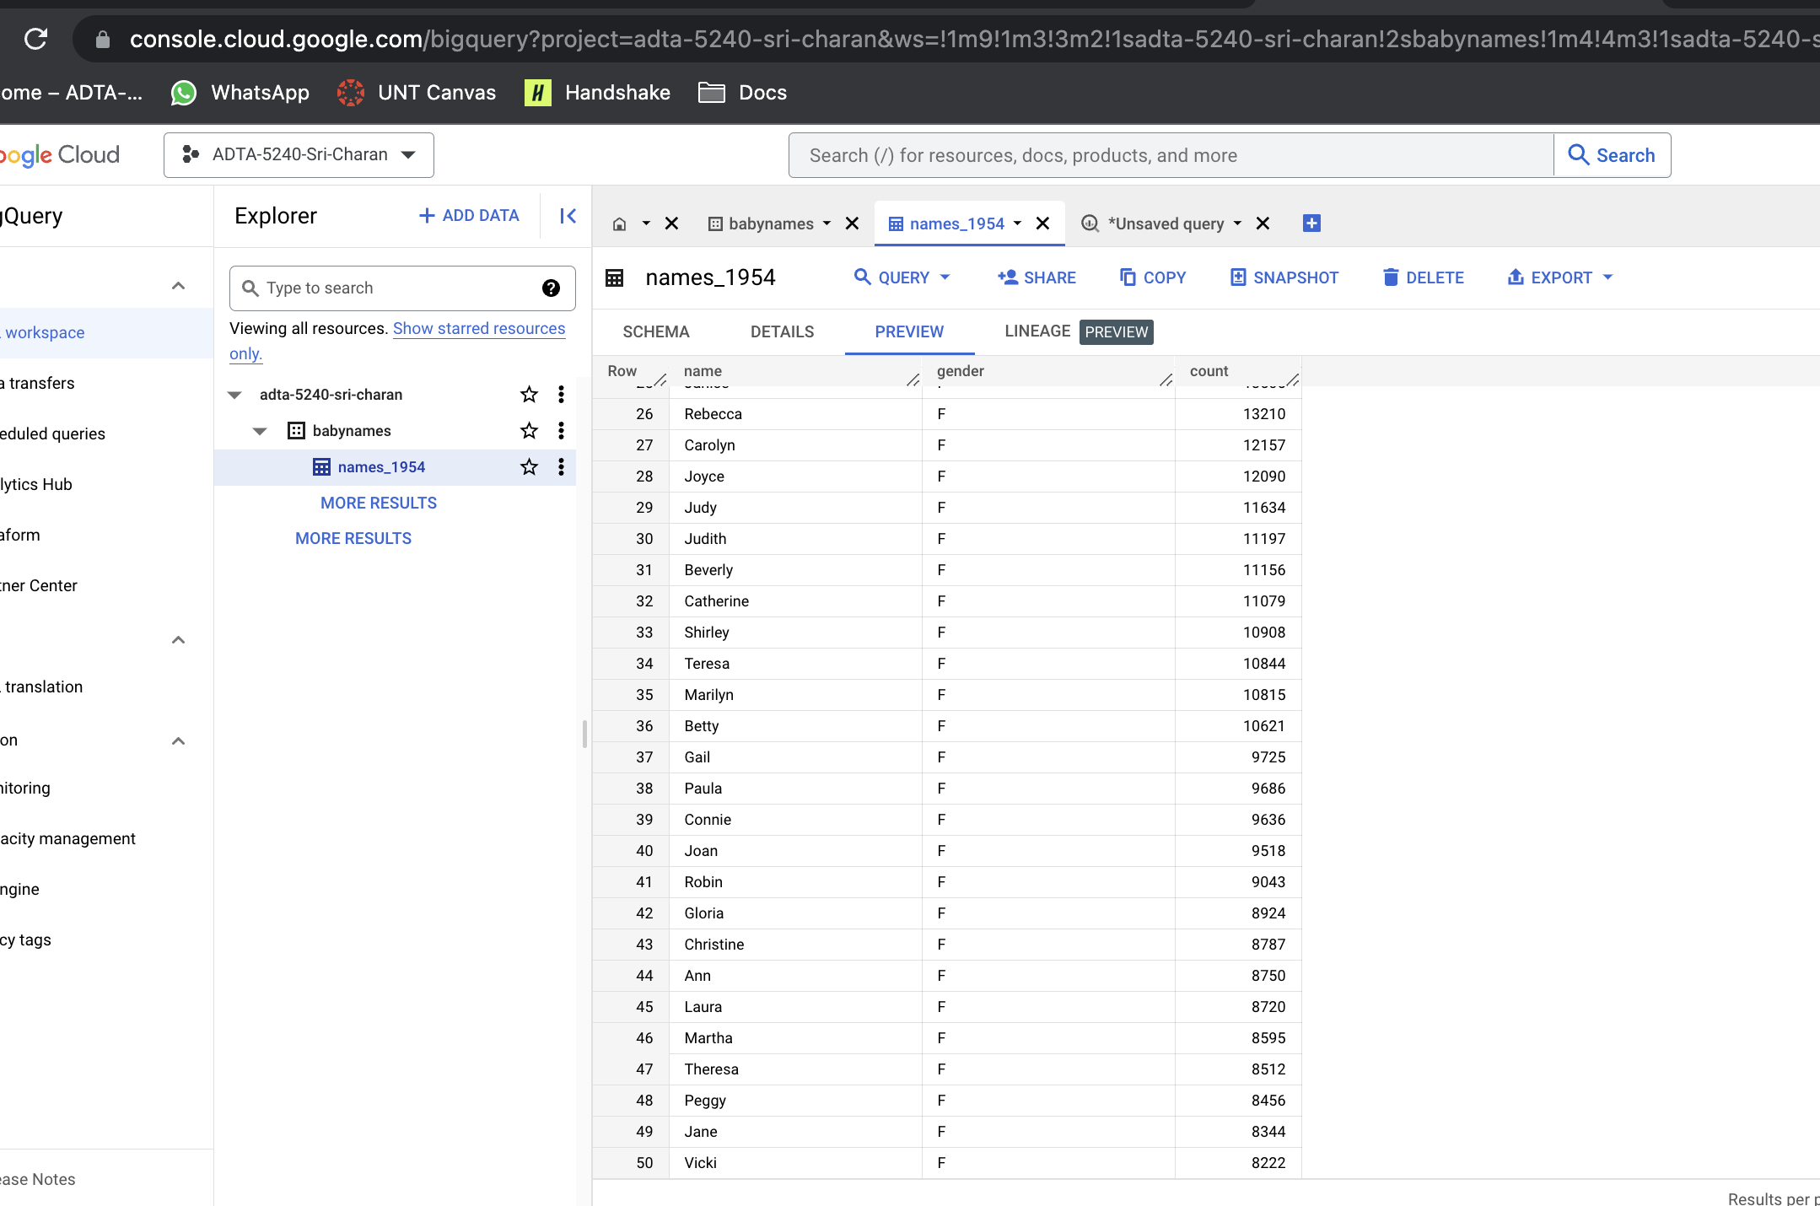

1. You can also query the table to see the data in it

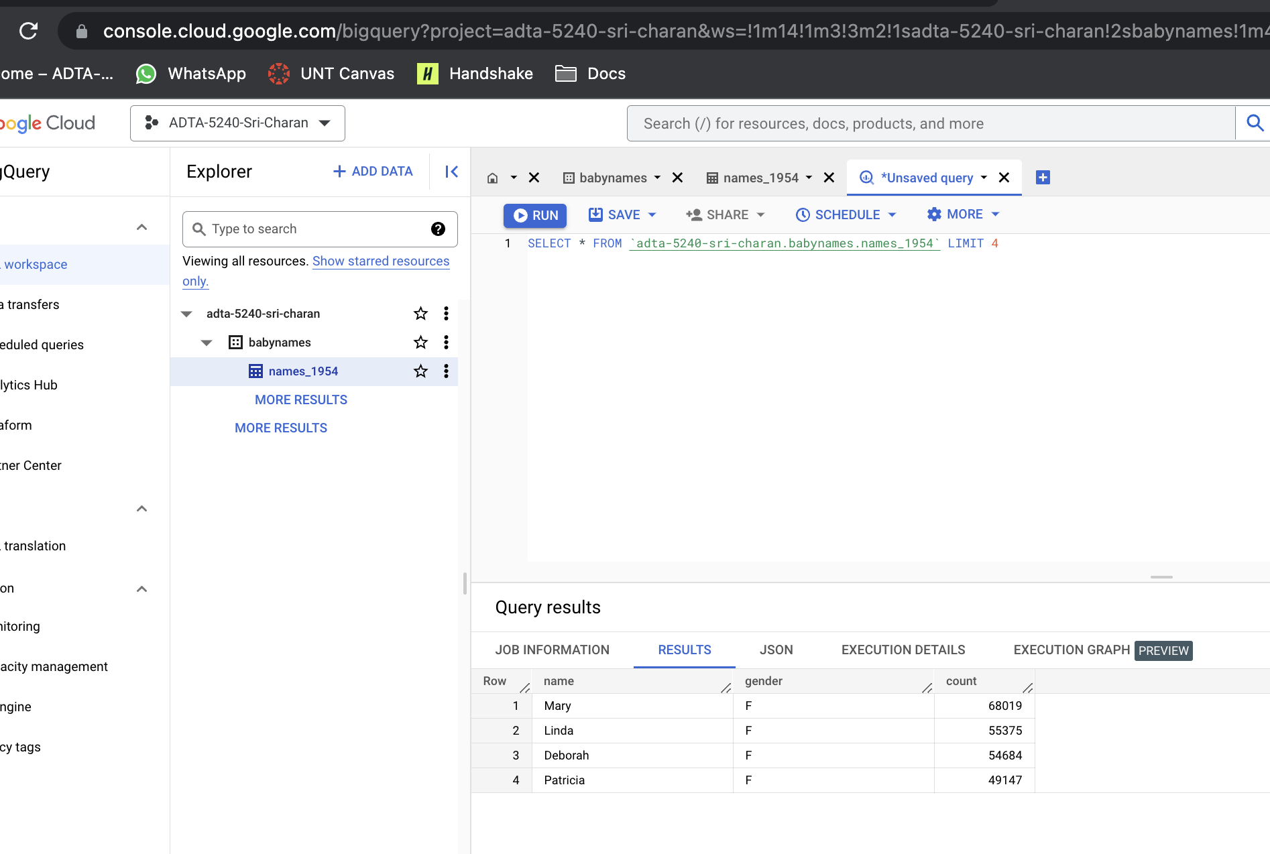

1. Make sure you delete the dataset once you have completed activity.

**Q9: MySQL**

1. Make sure you enable Cloud SQL API from marketplace

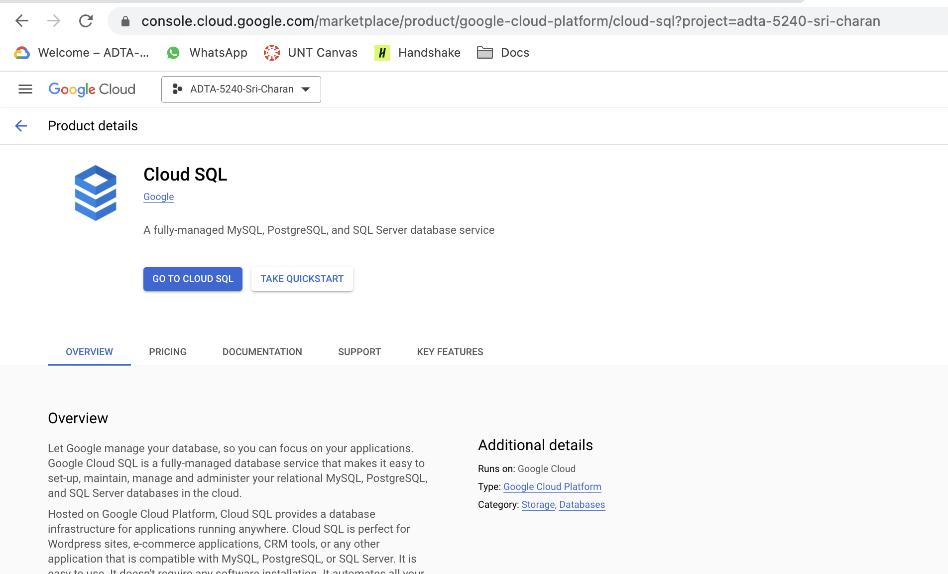

1. Click on “GO TO CLOUD SQL” to switch to Cloud SQL service on GCP
2. Click on “CREATE INSTANCE” to select MySQL service

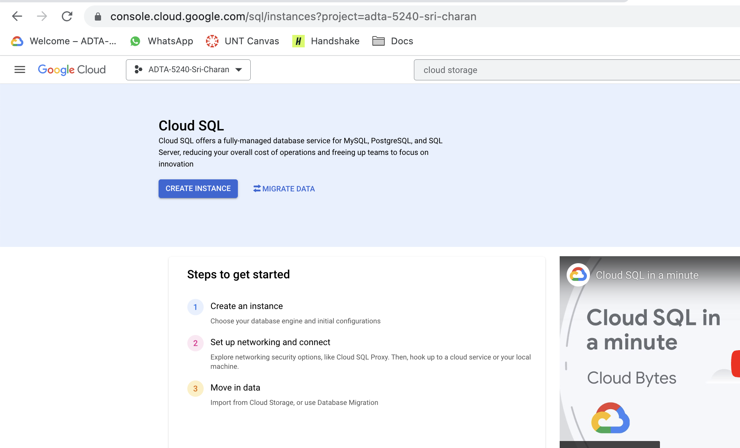

1. Choose “MySQL” as database engine

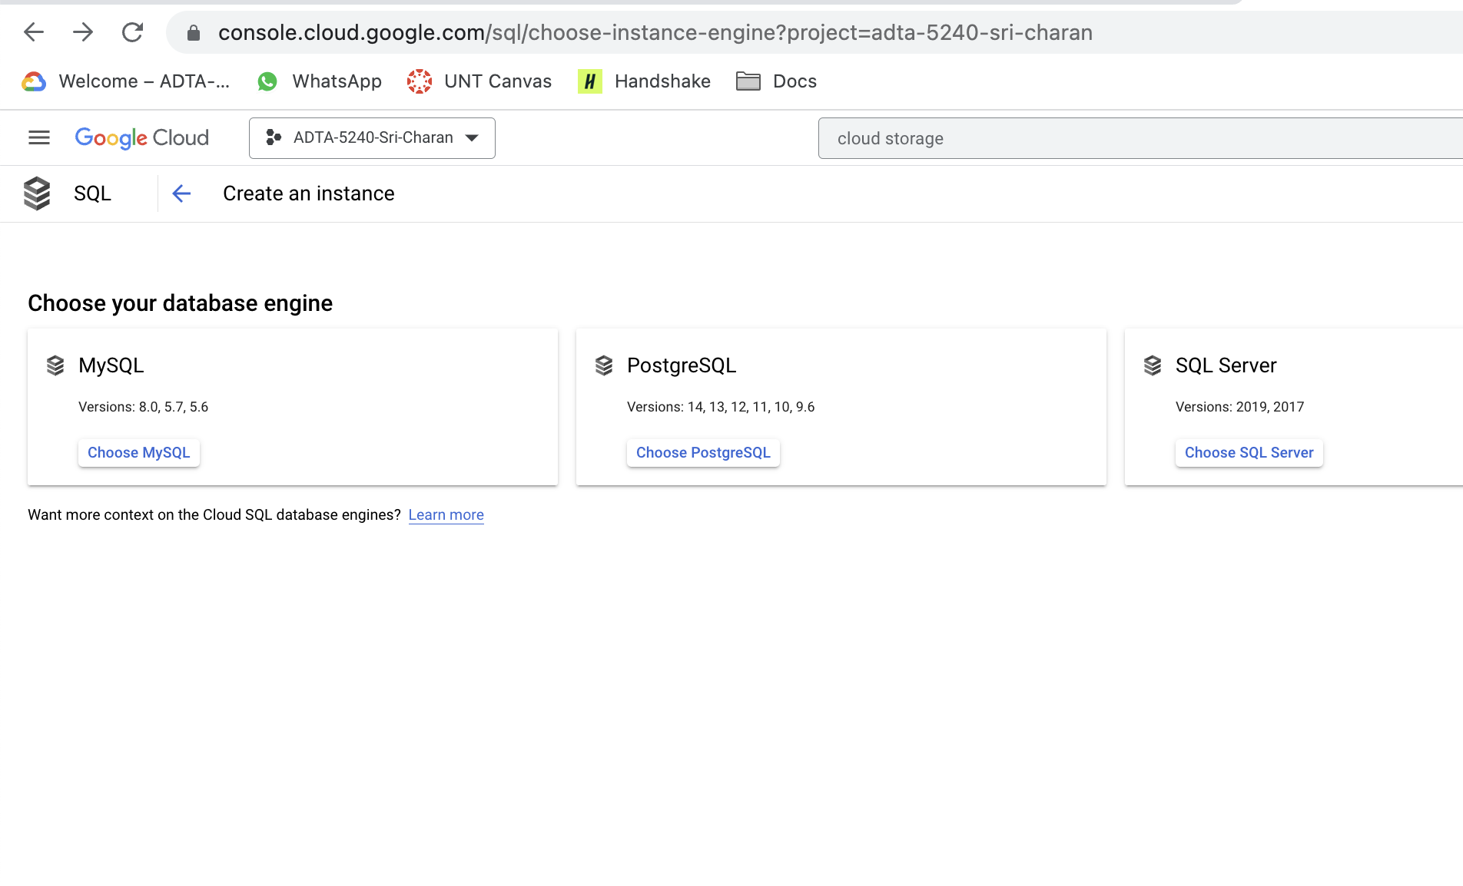

1. Give the name to MySQL instance and set all the configuration as below screenshot
2. I have given the name as “midterm-mysql-11661666”
3. Make sure you note or remember the password
4. Select database version as “MySQL 8.0”
5. Choose configuration as “Production” and region as “US” and multiple zones

Then click on “CREATE” button at the bottom

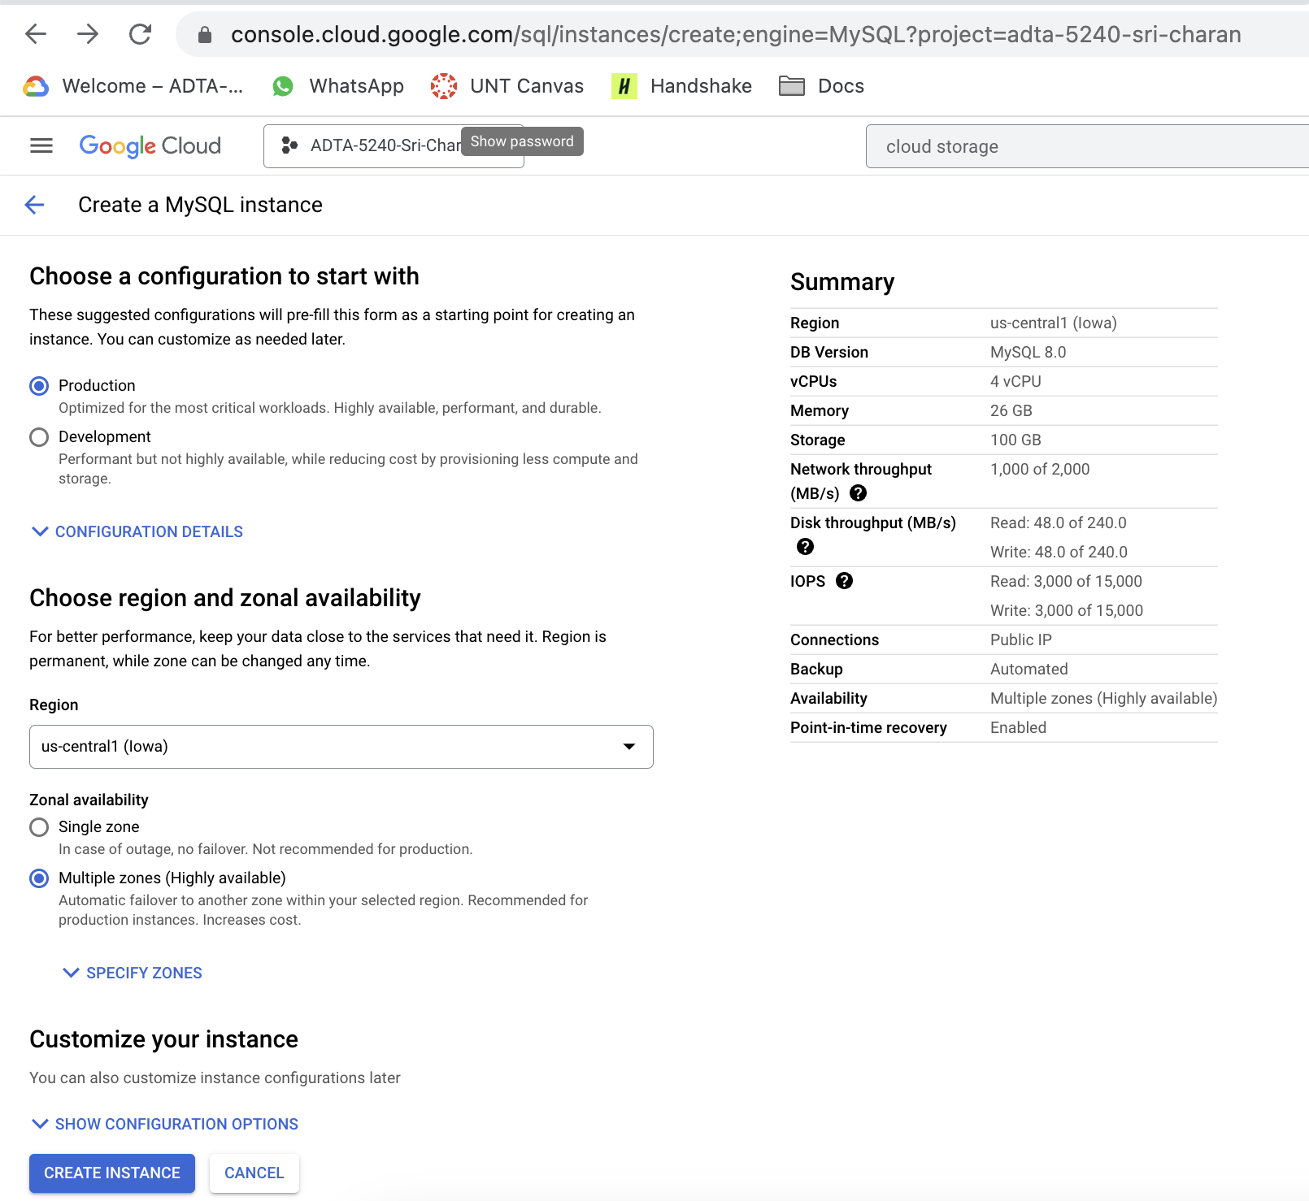

1. It will take few moments to initialize and set up MySQL. You can see running state once setup complete

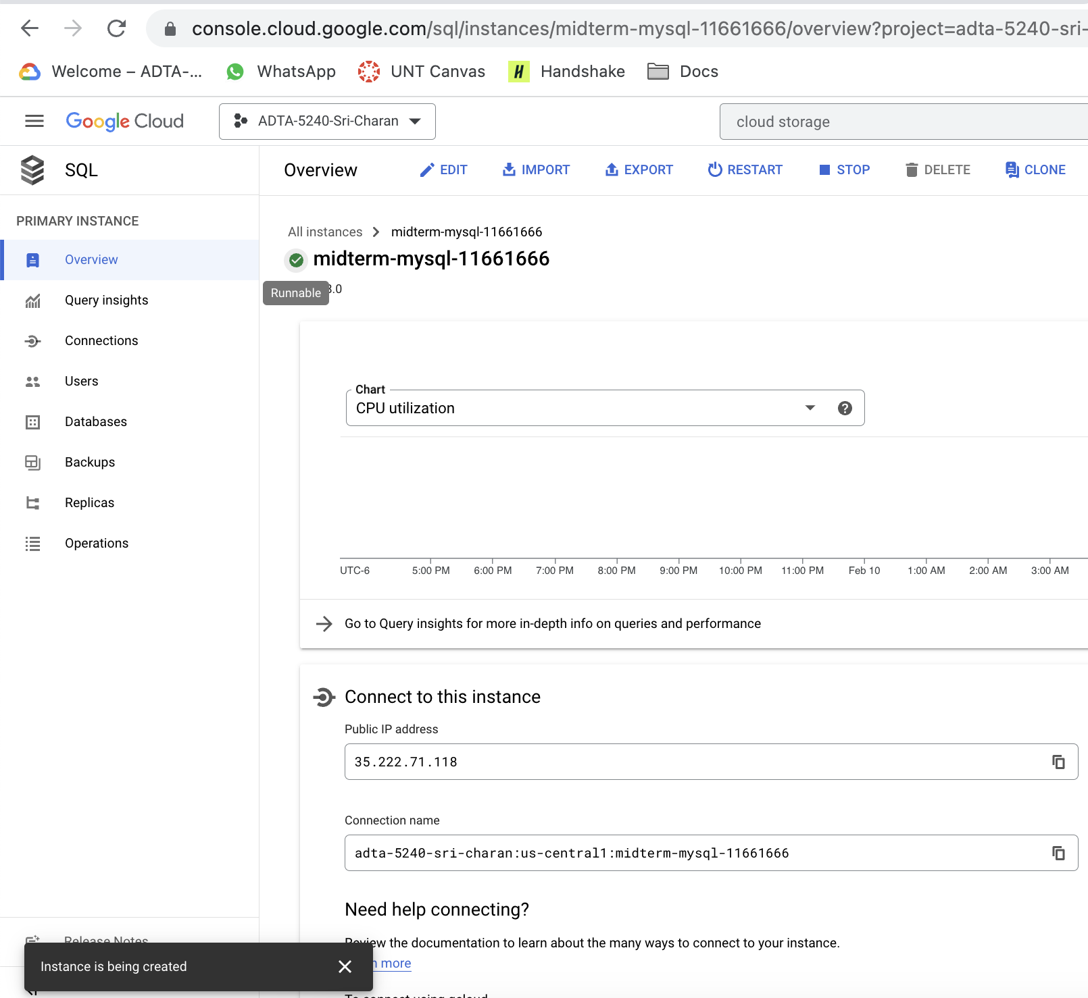

1. Click on “OPEN CLOUD SHELL” to open cloud command line interface(CLI) so that we can create database, table and insert rows

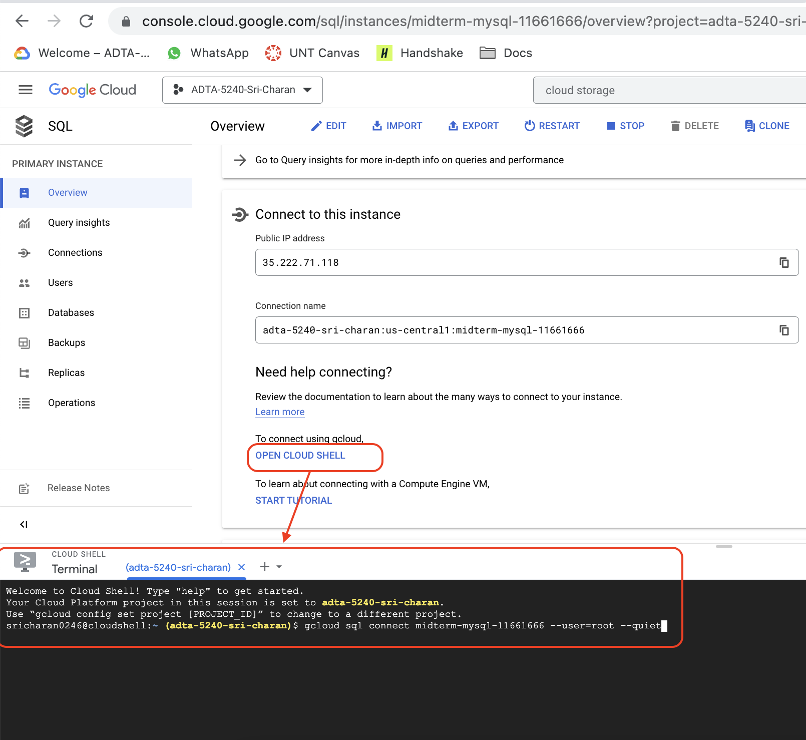

1. At first, you need to connect to MySQL instance using cloud instance. It asks for the password you need to enter password which we added during the time of instance creation

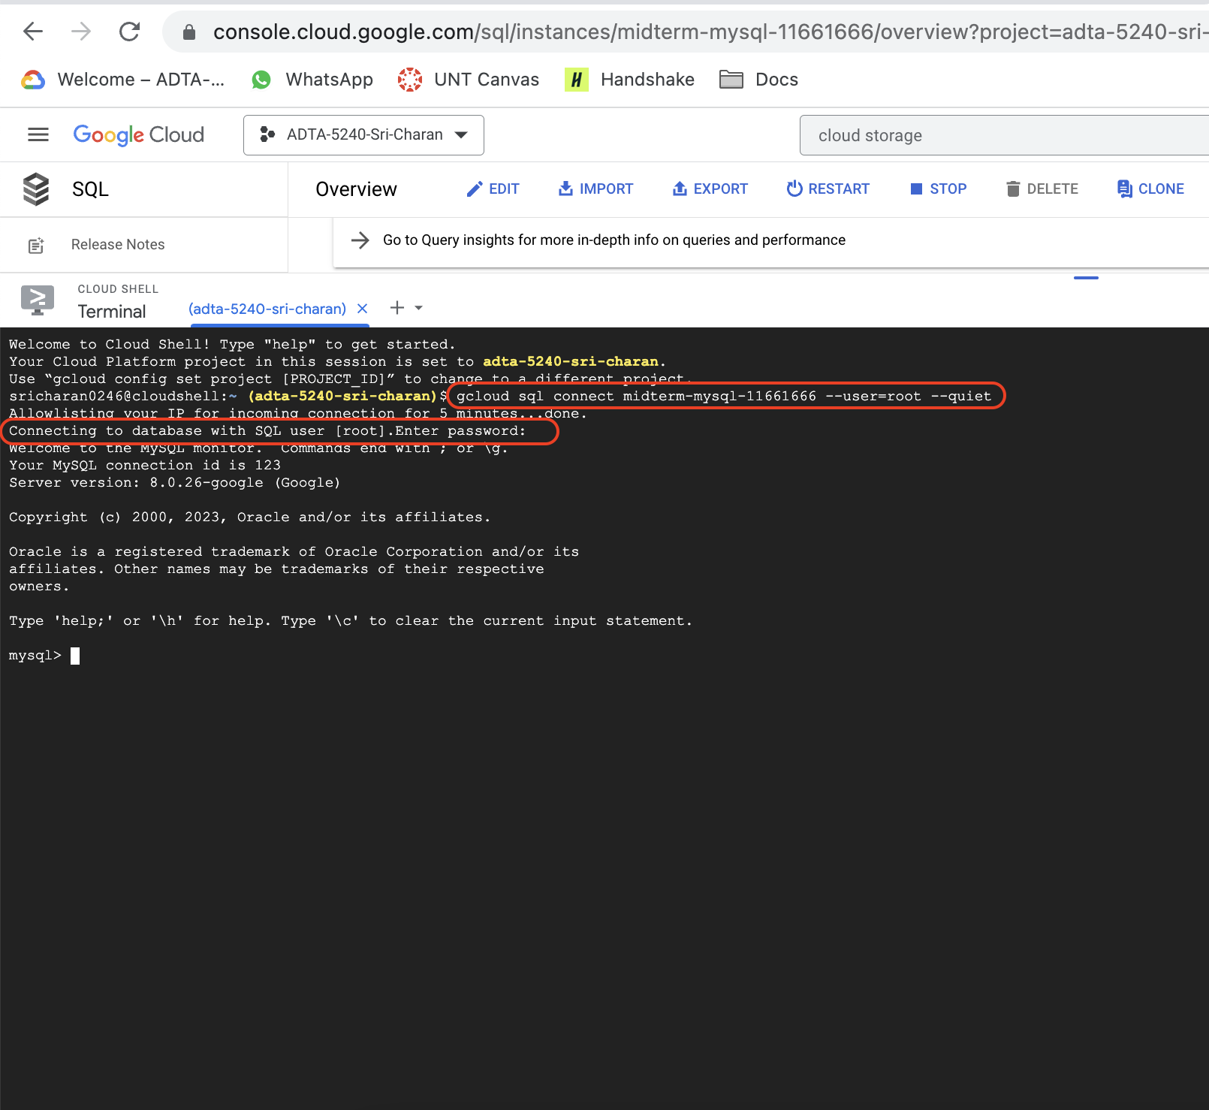

1. Now, create database by entering command:
2. CREATE DATABASE school;
3. To select newly created database: USE school;

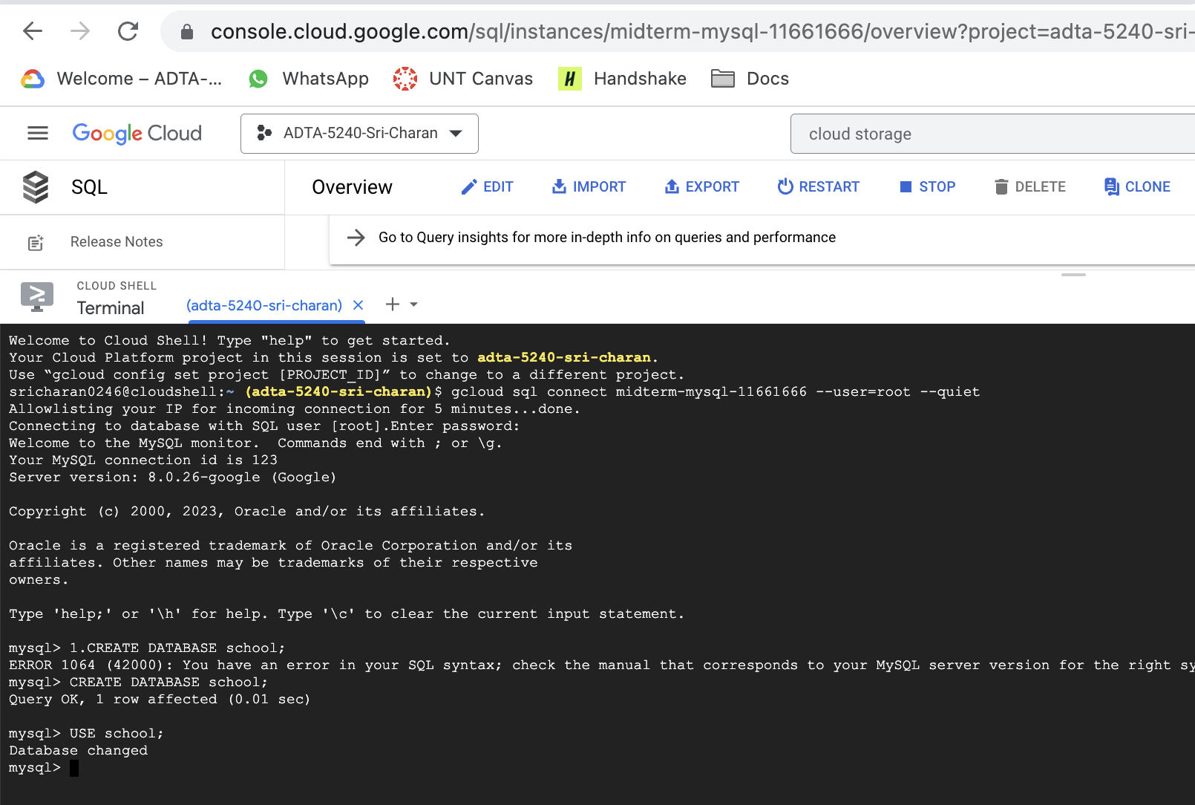

1. Now, create table, below is the query:

CREATE TABLE STUDENTS (SID INTEGER, FNAME VARCHAR(20), LNAME VARCHAR(20), AGE INTEGER, PROGRAM VARCHAR(20), PHONE_NO VARCHAR(20), CITY VARCHAR(20), STATE VARCHAR(20));

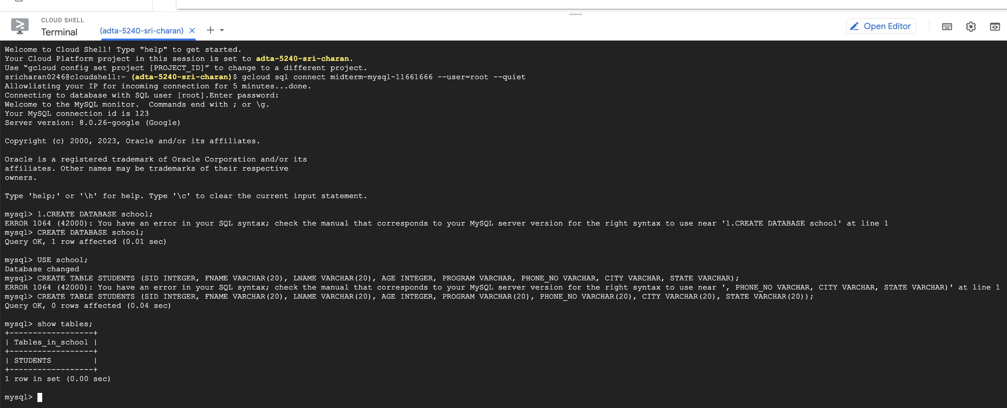

1. Insert few rows into STUDENTS table. Below is the insert query

INSERT INTO STUDENTS VALUES(1, "JOHN", "CURY", 24, "ADTA", "1998877661", "DENTON", "TEXAS");

INSERT INTO STUDENTS VALUES(2, "JOE", "WARNER", 26, "DATASCIENCE", "1998877662", "DALLAS", "TEXAS");

INSERT INTO STUDENTS VALUES(3, "JIM", "WATSON", 22, "BA", "1998877663", "HOUSTON", "TEXAS");

INSERT INTO STUDENTS VALUES(4, "JACK", "DOE", 28, "ADTA", "1998877664", "AUSTIN", "TEXAS");

INSERT INTO STUDENTS VALUES(5, "ROSS", "KELLY", 27, "ADTA", "1998877665", "TAMPA", "FLORIDA");

INSERT INTO STUDENTS VALUES(6, "SAM", "HEAT", 24, "CS", "1998877666", "CURY", "NORTH CAROLINA");

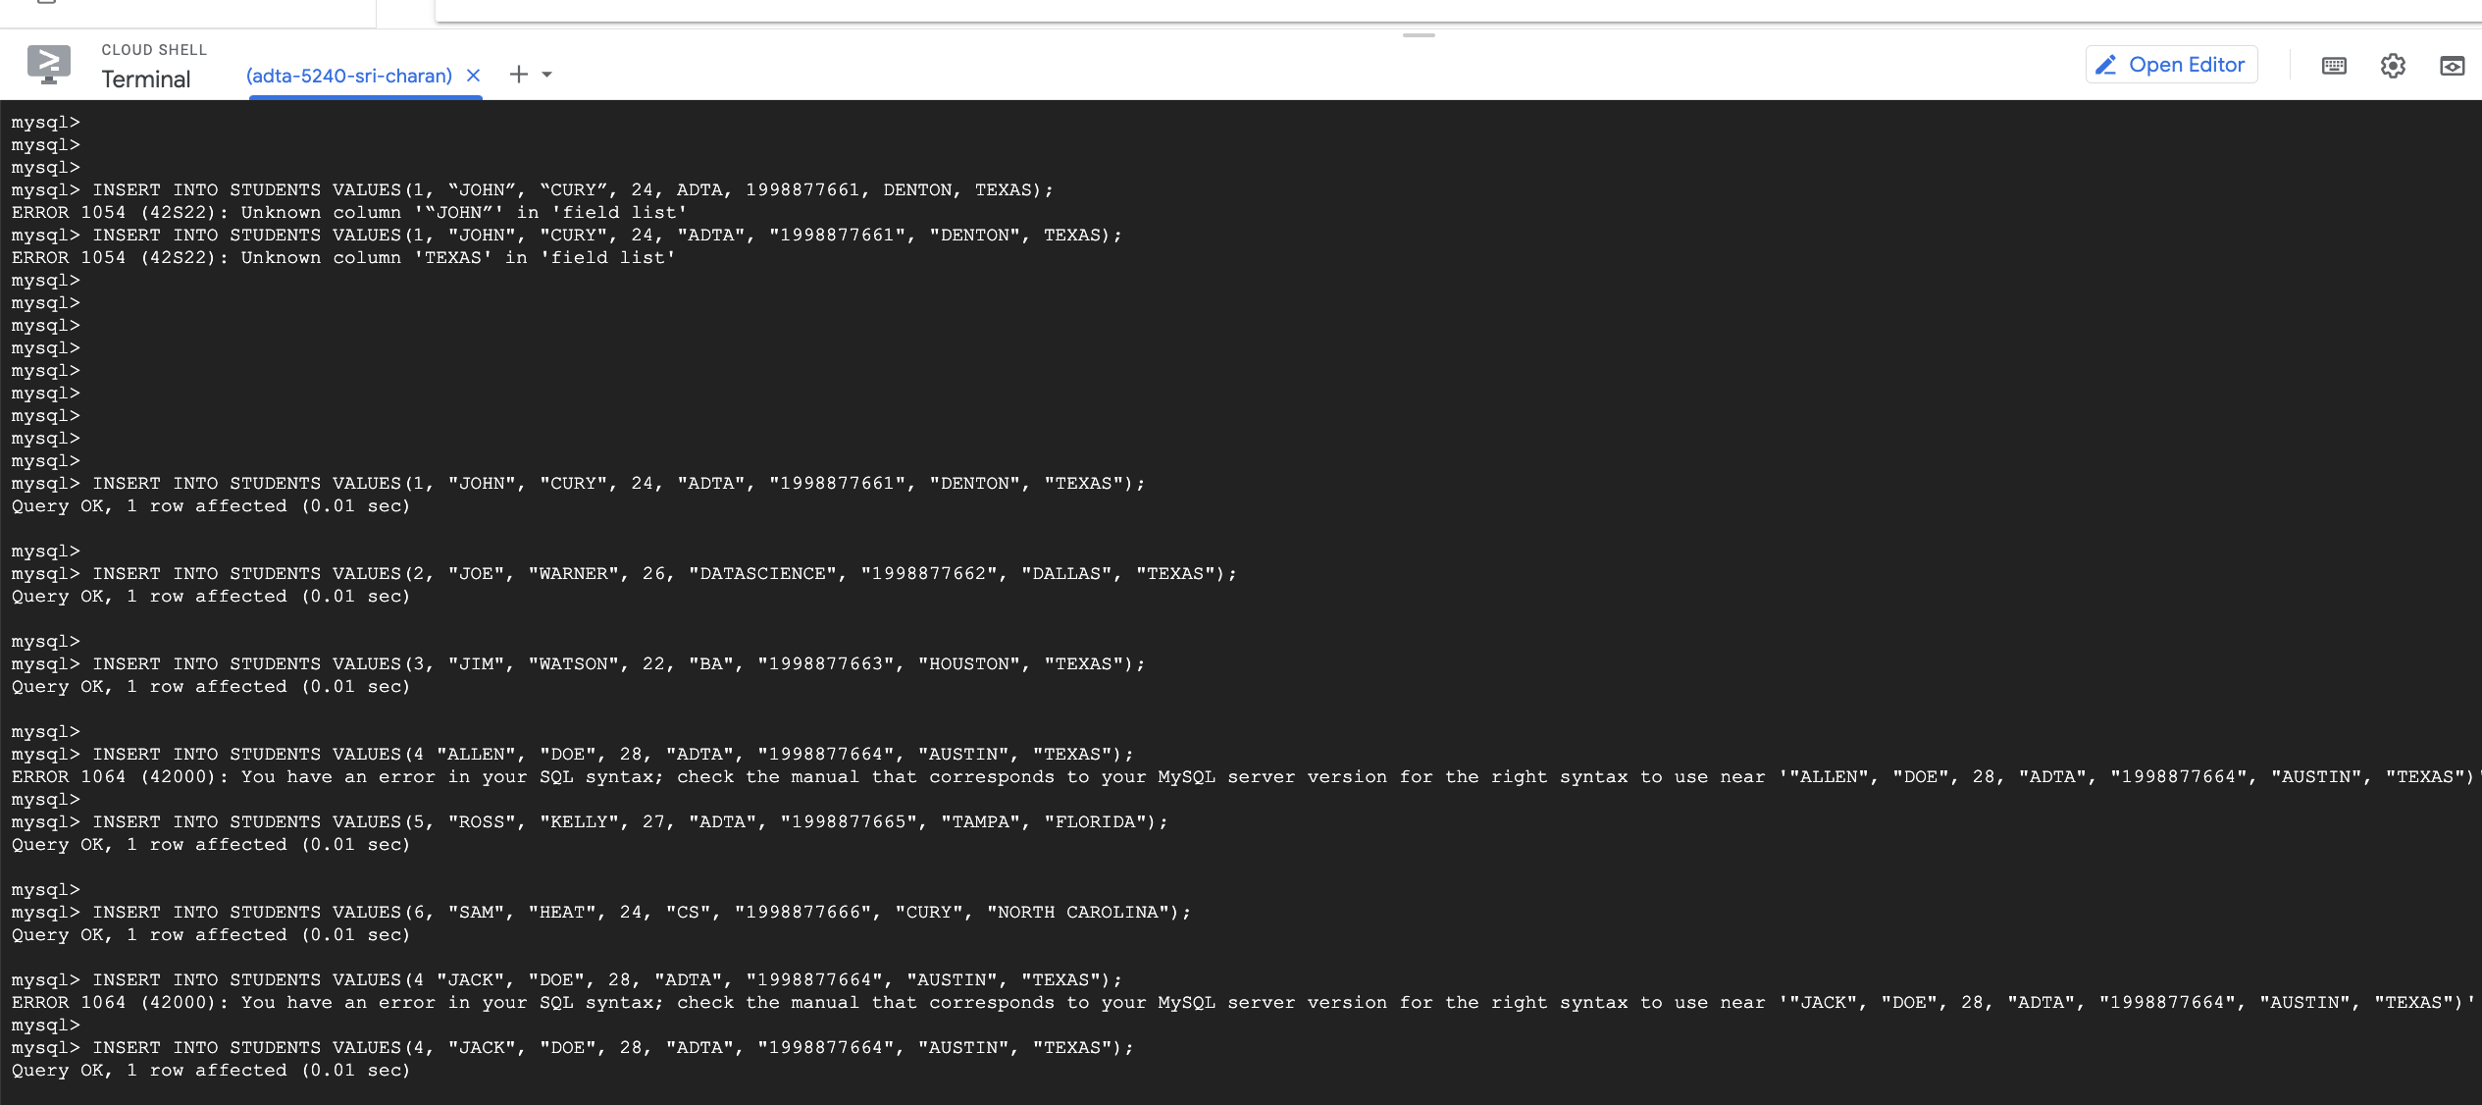

1. You can view the data inside the table by following query

SELECT * FROM STUDENTS;

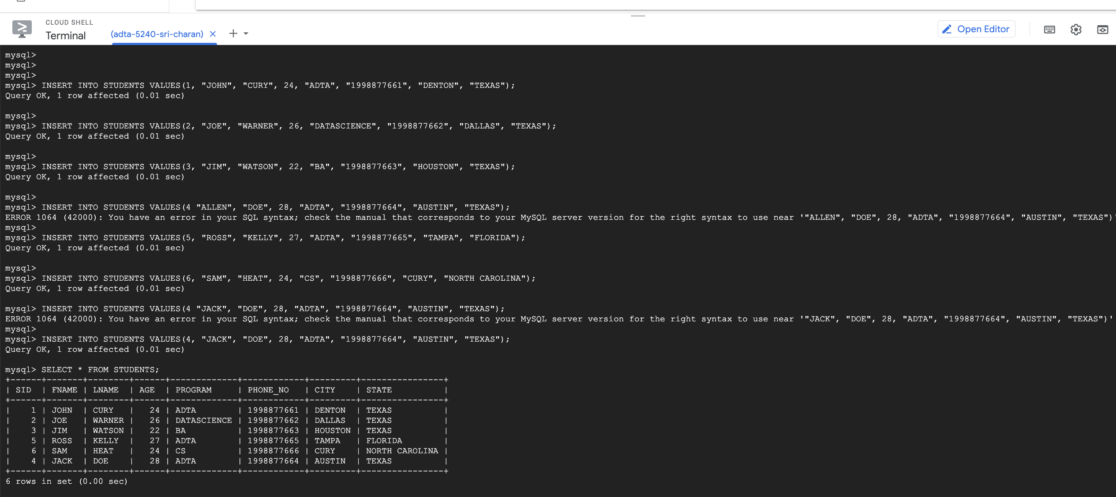

**Note:** Make sure you delete the instance after use to minimize costs.

**Q10: Cloud Storage**

1. You can navigate to Cloud storage service by 2 ways. You can click on hamburger icon on left side of screen and scroll to “Cloud Storage” and select it. Secondly, you can search “cloud storage” on top search bar.

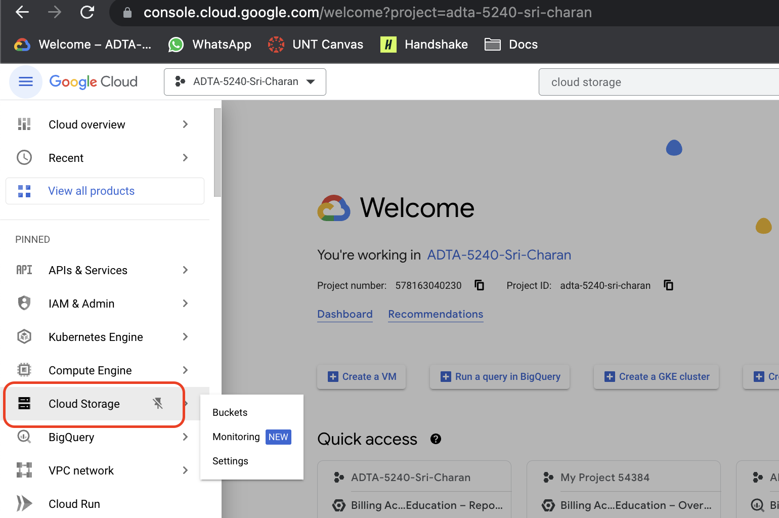

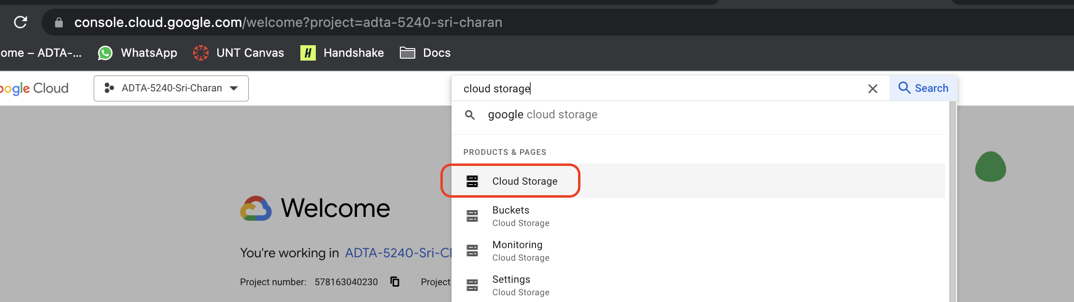

1. Under cloud storage home page, you see see CREATE button to create new bucket

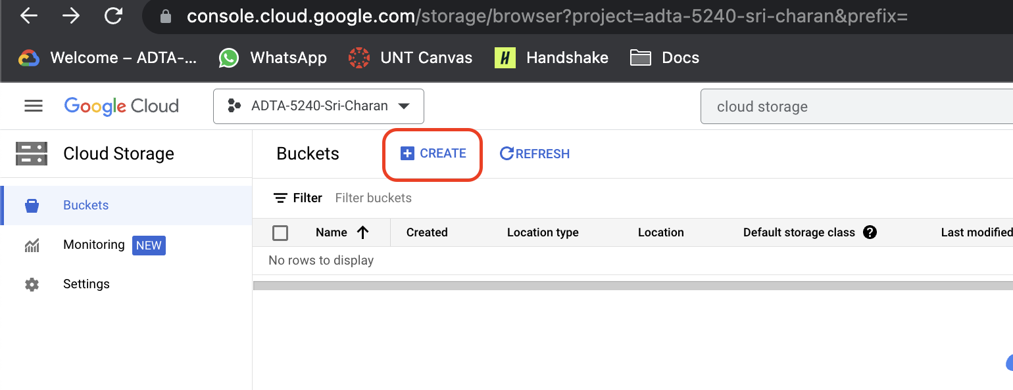

1. Give the name to the bucket and set the configurations as below screenshot
   1. Name must not have spaces and must be in lowercase I have given “midterm-practical-11661666”
   2. Set local as multiregion and set US as multiregion location – this is required to locate the bucket in particular region so that latency is minimum
   3. Select “Standard” as storage class – this is required to set to define how the storing to be done
   4. Select “Uniform” as access control to inherit common access controls defined for cloud storage
   5. At last, define how to protect the data to set up protection policies. For now, you can select now.

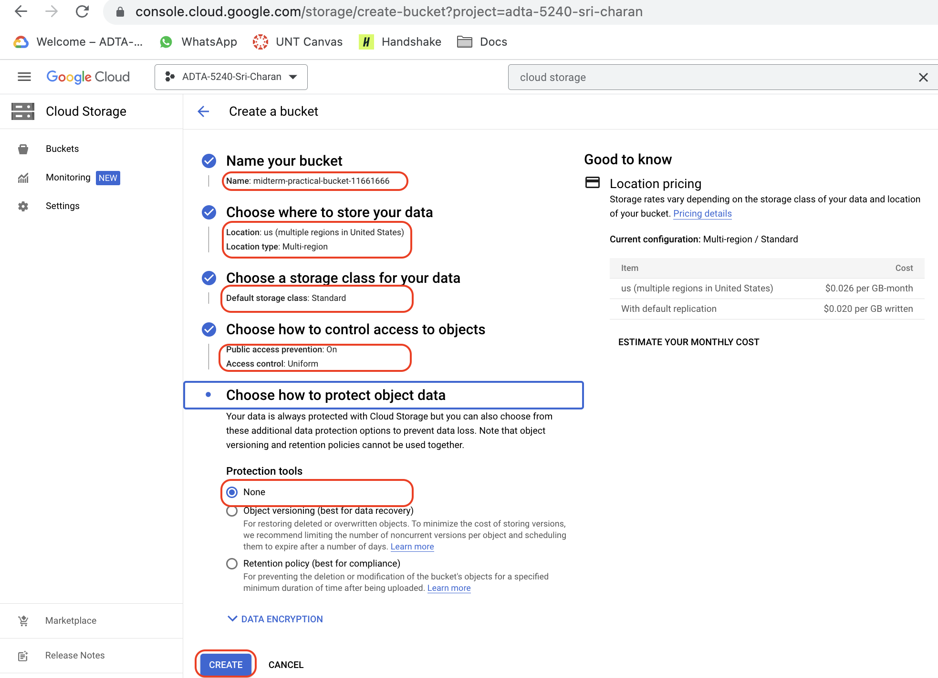

Now, a dialog box is shown to confirm public access to the bucket. You can select enforce public access prevention on this bucket. click on confirm

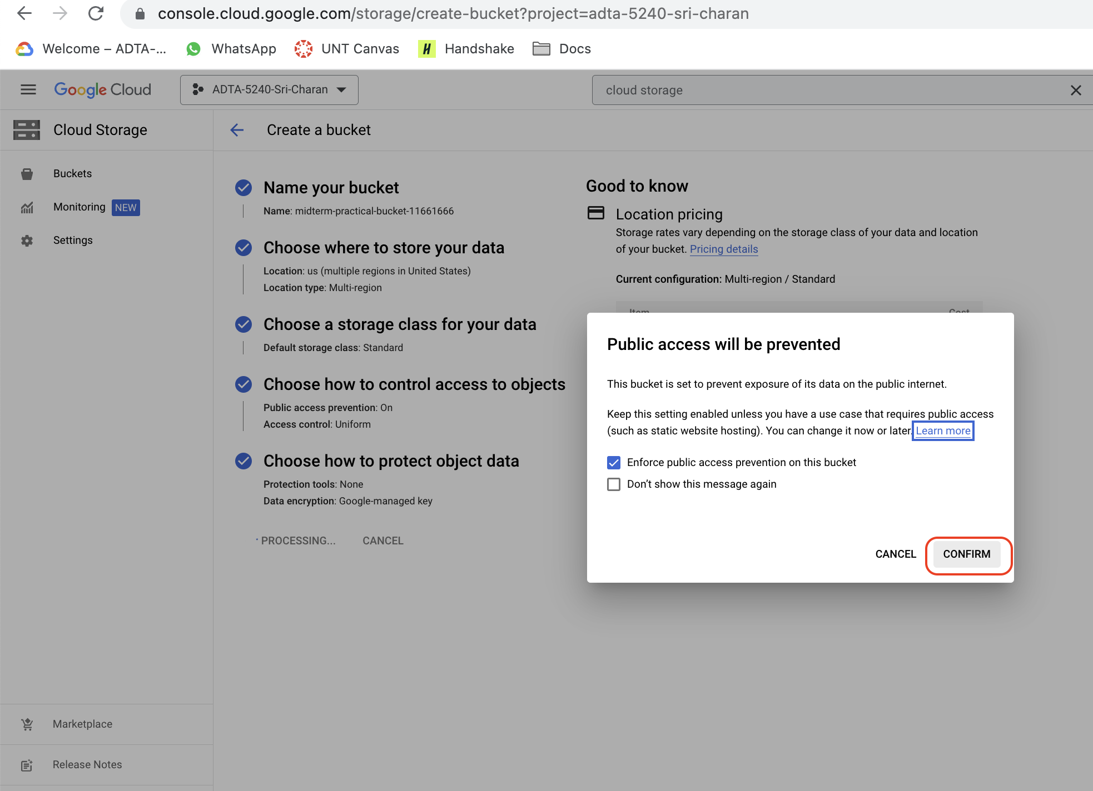

1. Bucket has been created successfully.

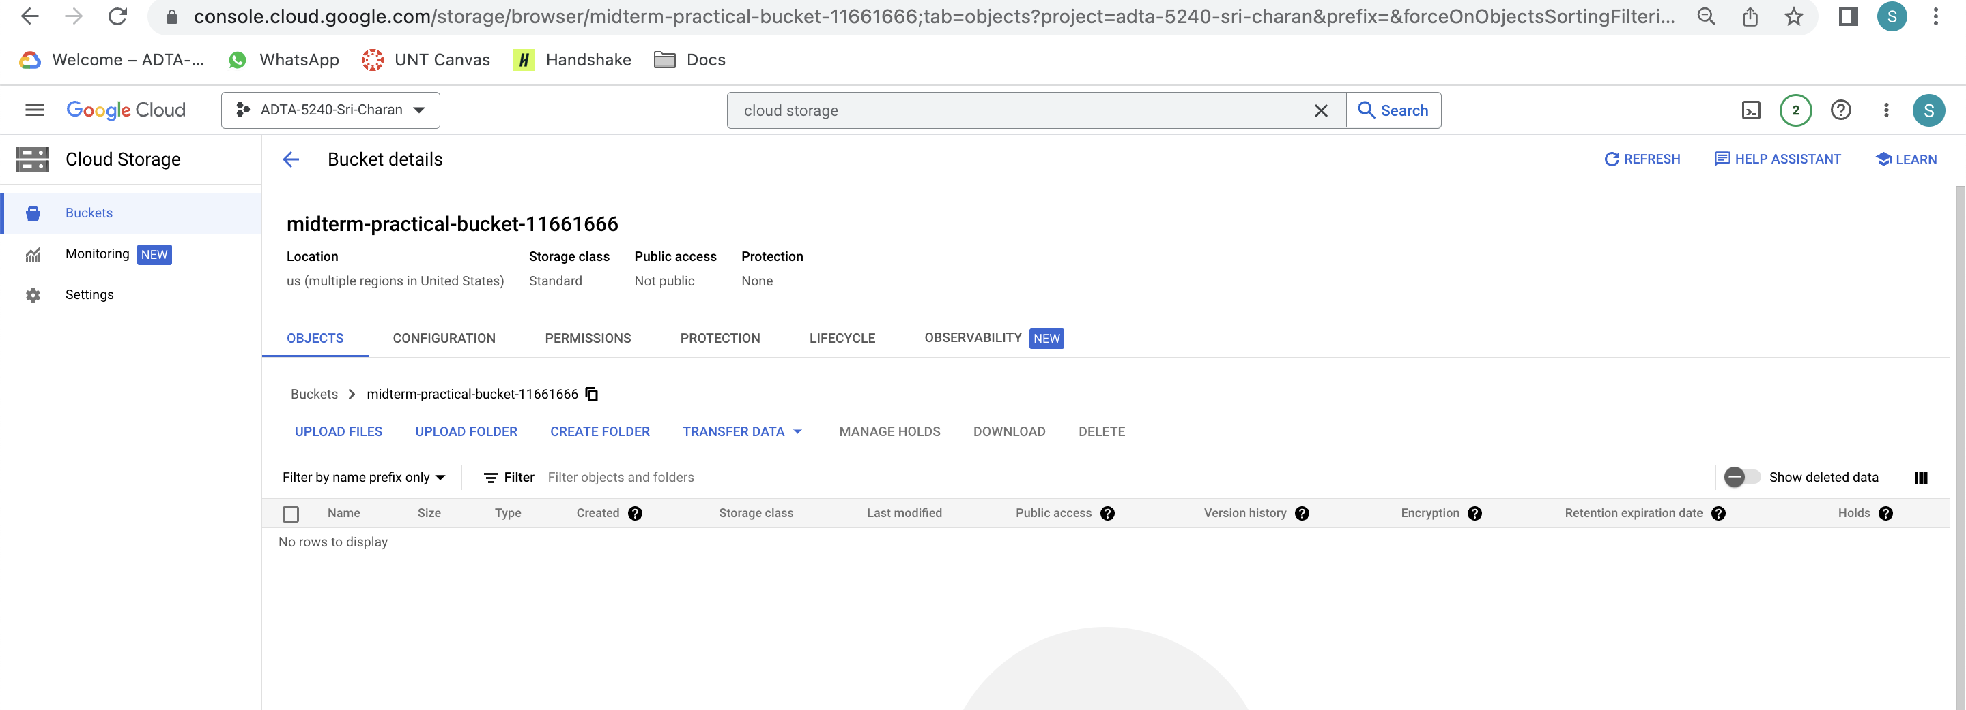

1. Now, load some file into the bucket. First, create a folder in the newly created bucket. Click on “CREATE FOLDER” button on top bar, give name to it and click on CREATE button

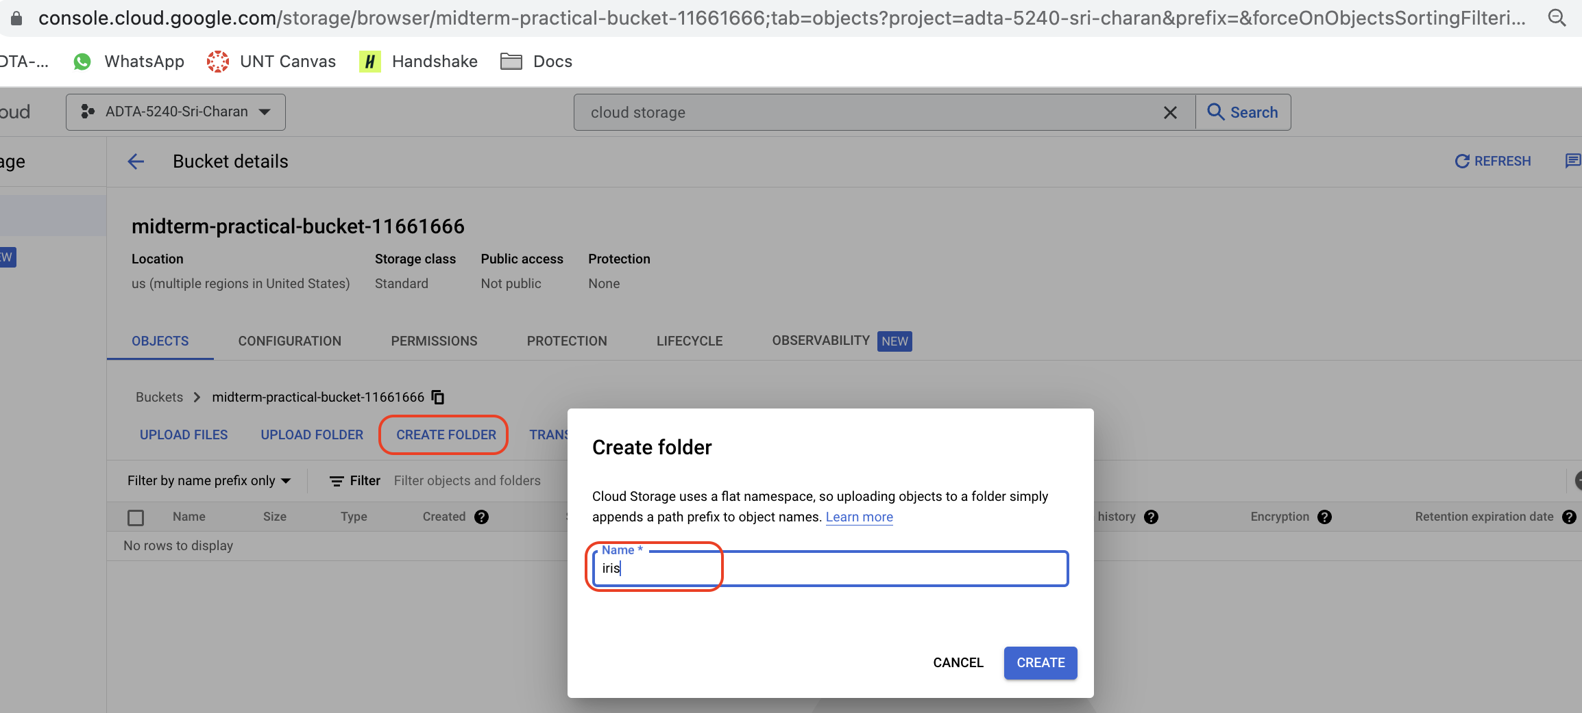

1. Folder has been created

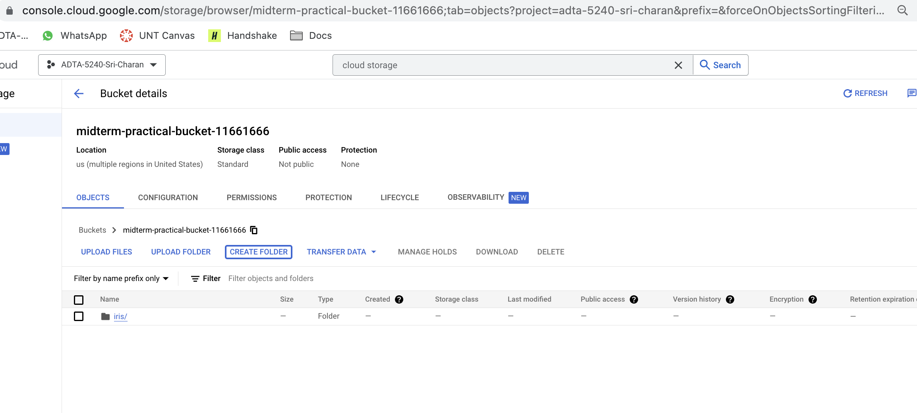

1. Go into the folder “iris” and click on upload files

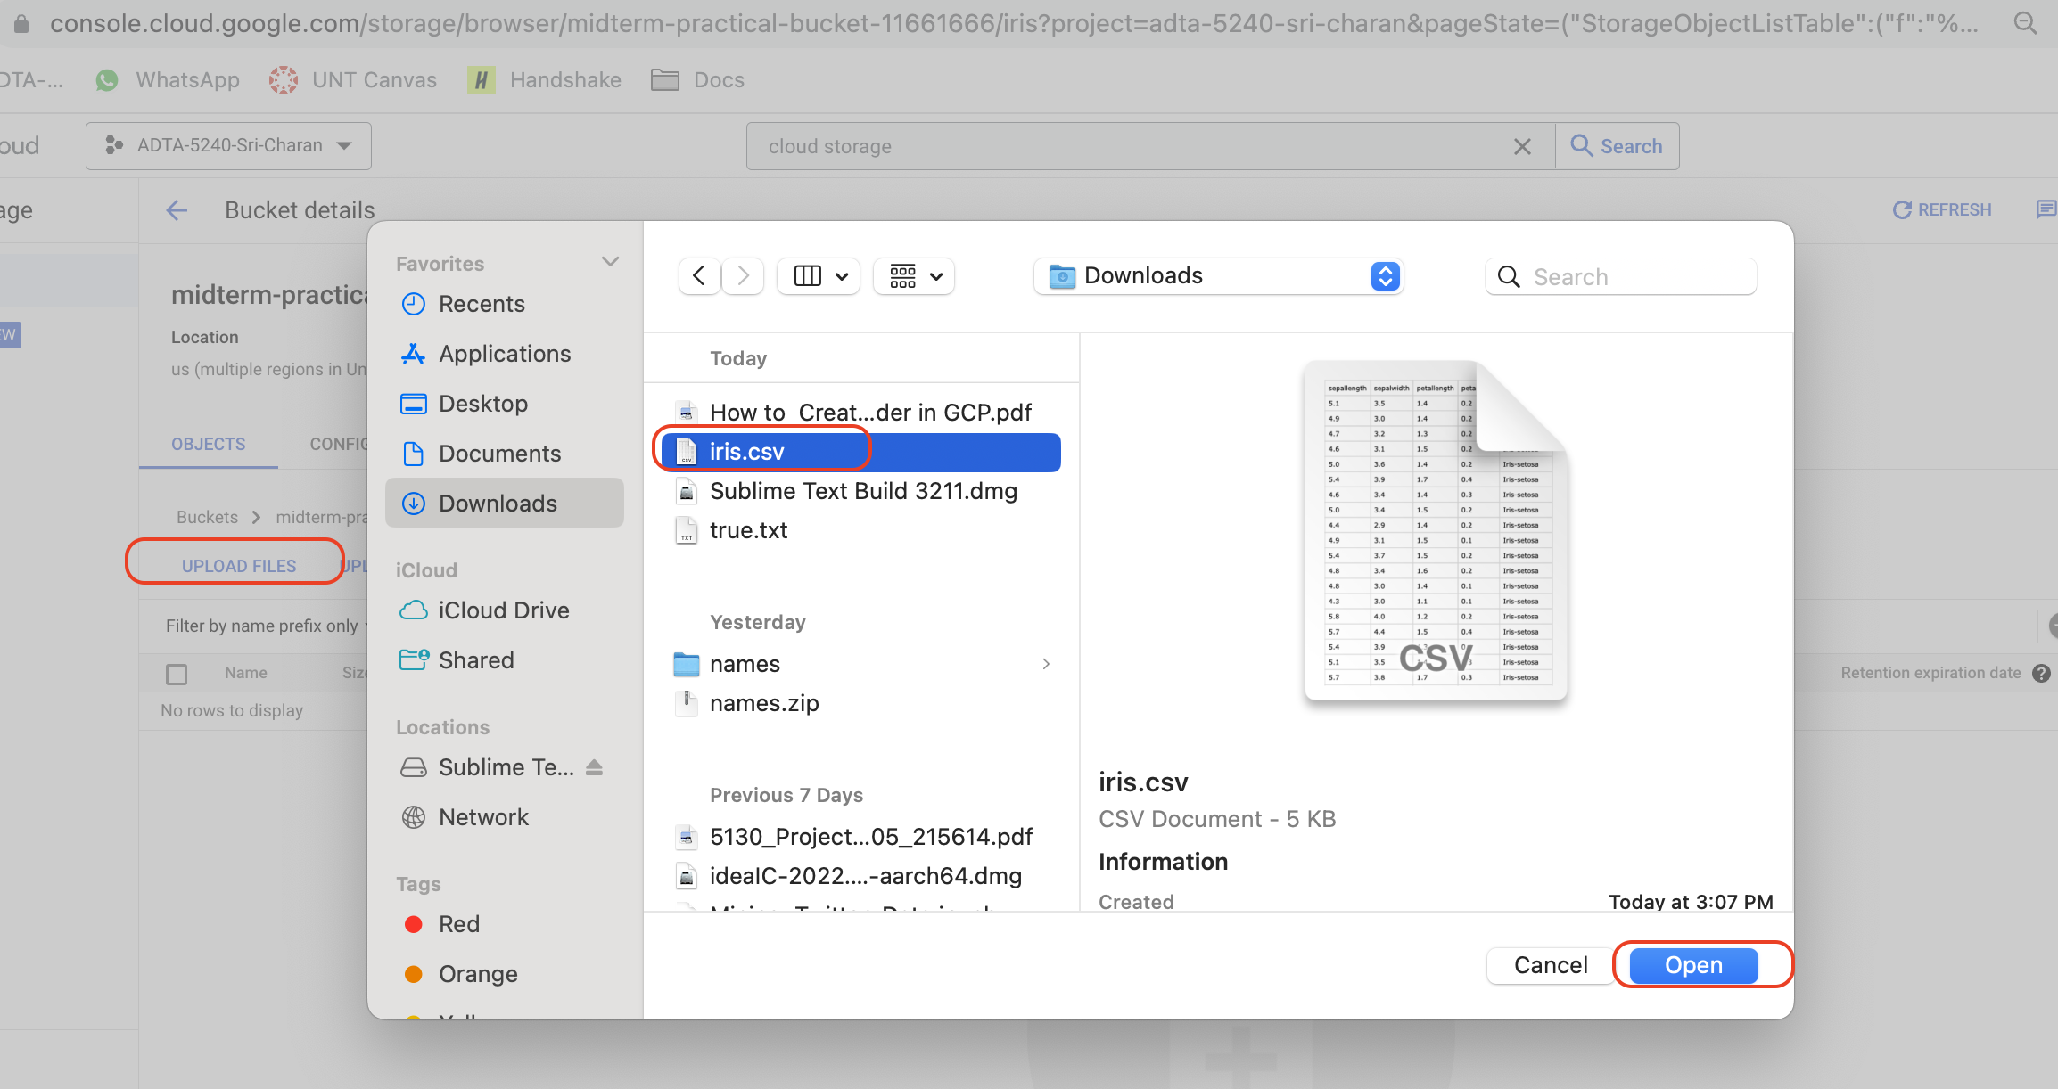

1. Now, you see below file uploaded into cloud storage

